LE and YLL manuscript results

Table 1: 5-year net survival probability estimates for each cancer type, stage, age at diagnosis and gender combinations
Gender | Cancer type | Stage | 50-54 | 55-59 | 60-64 | 65-69 | 70-74 | 75-79
Female | Anus | I | 0.944 | 0.926 | 0.952 | 0.928 | 0.821 | 0.826
 |  | II | 0.838 | 0.870 | 0.898 | 0.820 | 0.766 | 0.711
 |  | III | 0.762 | 0.701 | 0.713 | 0.706 | 0.552 | 0.597
 |  | IV | 0.174 | 0.171 | 0.166 | 0.246 | 0.148 | 0.085
 | Bladder | I | 0.881 | 0.887 | 0.882 | 0.852 | 0.807 | 0.796
 |  | II | 0.553 | 0.584 | 0.541 | 0.538 | 0.521 | 0.423
 |  | III | 0.471 | 0.567 | 0.468 | 0.504 | 0.450 | 0.360
 |  | IV | 0.255 | 0.144 | 0.136 | 0.158 | 0.120 | 0.087
 | Breast | I | 0.989 | 0.994 | 0.995 | 0.999 | 1.000 | 1.000
 |  | II | 0.941 | 0.936 | 0.937 | 0.946 | 0.916 | 0.906
 |  | III | 0.800 | 0.800 | 0.801 | 0.780 | 0.723 | 0.656
 |  | IV | 0.399 | 0.331 | 0.320 | 0.275 | 0.227 | 0.208
 | Cervix | I | 0.961 | 0.970 | 0.868 | 0.866 | 0.997 | 0.816
 |  | II | 0.702 | 0.733 | 0.742 | 0.748 | 0.445 | 0.612
 |  | III | 0.314 | 0.509 | 0.458 | 0.441 | 0.262 | 0.143
 |  | IV | 0.247 | 0.199 | 0.199 | 0.176 | 0.122 | 0.000
 | Colon/Rectum | I | 0.962 | 0.961 | 0.960 | 0.962 | 0.963 | 0.920
 |  | II | 0.894 | 0.891 | 0.893 | 0.861 | 0.868 | 0.819
 |  | III | 0.765 | 0.747 | 0.755 | 0.716 | 0.689 | 0.600
 |  | IV | 0.162 | 0.142 | 0.149 | 0.126 | 0.128 | 0.072
 | Esophagus | I | 0.740 | 0.656 | 0.649 | 0.616 | 0.528 | 0.493
 |  | II | 0.441 | 0.449 | 0.406 | 0.369 | 0.351 | 0.310
 |  | III | 0.241 | 0.205 | 0.219 | 0.229 | 0.175 | 0.155
 |  | IV | 0.029 | 0.037 | 0.037 | 0.026 | 0.030 | 0.017
 | Gallbladder | I | 0.654 | 0.620 | 0.772 | 0.578 | 0.489 | 0.311
 |  | II | 0.388 | 0.381 | 0.383 | 0.436 | 0.399 | 0.384
 |  | III | 0.211 | 0.260 | 0.308 | 0.188 | 0.151 | 0.108
 |  | IV | 0.032 | 0.062 | 0.022 | 0.019 | 0.027 | 0.000
 | Head and Neck | I | 0.862 | 0.881 | 0.885 | 0.912 | 0.909 | 0.883
 |  | II | 0.867 | 0.779 | 0.757 | 0.778 | 0.647 | 0.668
 |  | III | 0.775 | 0.717 | 0.687 | 0.666 | 0.590 | 0.527
 |  | IV | 0.626 | 0.576 | 0.512 | 0.436 | 0.352 | 0.302
 | Kidney | I | 0.960 | 0.952 | 0.937 | 0.923 | 0.906 | 0.862
 |  | II | 0.914 | 0.932 | 0.899 | 0.839 | 0.835 | 0.728
 |  | III | 0.794 | 0.788 | 0.789 | 0.786 | 0.764 | 0.720
 |  | IV | 0.208 | 0.183 | 0.170 | 0.150 | 0.114 | 0.101
 | Liver/Bile-duct | I | 0.598 | 0.465 | 0.464 | 0.541 | 0.532 | 0.215
 |  | II | 0.310 | 0.419 | 0.393 | 0.343 | 0.303 | 0.352
 |  | III | 0.119 | 0.140 | 0.187 | 0.123 | 0.030 | 0.101
 |  | IV | 0.022 | 0.042 | 0.032 | 0.017 | 0.021 | 0.027
 | Lung | I | 0.772 | 0.690 | 0.674 | 0.643 | 0.549 | 0.479
 |  | II | 0.469 | 0.525 | 0.484 | 0.390 | 0.312 | 0.270
 |  | III | 0.235 | 0.180 | 0.175 | 0.138 | 0.112 | 0.096
 |  | IV | 0.055 | 0.045 | 0.035 | 0.027 | 0.023 | 0.018
 | Lymphoma | I | 0.929 | 0.903 | 0.889 | 0.869 | 0.799 | 0.792
 |  | II | 0.909 | 0.904 | 0.851 | 0.826 | 0.778 | 0.643
 |  | III | 0.864 | 0.822 | 0.768 | 0.722 | 0.682 | 0.527
 |  | IV | 0.767 | 0.726 | 0.708 | 0.674 | 0.615 | 0.539
 | Melanoma | I | 0.996 | 0.998 | 1.000 | 1.000 | 1.000 | 1.000
 |  | II | 0.861 | 0.799 | 0.803 | 0.802 | 0.804 | 0.804
 |  | III | 0.766 | 0.673 | 0.685 | 0.689 | 0.660 | 0.668
 |  | IV | 0.418 | 0.272 | 0.303 | 0.244 | 0.272 | 0.298
 | Ovary | I | 0.921 | 0.948 | 0.946 | 0.925 | 0.942 | 0.920
 |  | II | 0.707 | 0.761 | 0.830 | 0.676 | 0.744 | 0.545
 |  | III | 0.441 | 0.349 | 0.336 | 0.311 | 0.231 | 0.188
 |  | IV | 0.259 | 0.211 | 0.213 | 0.161 | 0.138 | 0.096
 | Pancreas | I | 0.657 | 0.492 | 0.375 | 0.353 | 0.249 | 0.185
 |  | II | 0.261 | 0.198 | 0.177 | 0.206 | 0.157 | 0.162
 |  | III | 0.087 | 0.109 | 0.032 | 0.051 | 0.056 | 0.047
 |  | IV | 0.043 | 0.037 | 0.019 | 0.012 | 0.009 | 0.007
 | Sarcoma | I | 0.893 | 0.887 | 0.799 | 0.810 | 0.693 | 0.712
 |  | II | 0.717 | 0.745 | 0.758 | 0.596 | 0.743 | 0.515
 |  | III | 0.492 | 0.533 | 0.575 | 0.509 | 0.517 | 0.355
 |  | IV | 0.212 | 0.052 | 0.035 | 0.076 | 0.033 | 0.054
 | Stomach | I | 0.749 | 0.679 | 0.648 | 0.758 | 0.698 | 0.683
 |  | II | 0.483 | 0.464 | 0.323 | 0.454 | 0.369 | 0.322
 |  | III | 0.345 | 0.311 | 0.261 | 0.288 | 0.229 | 0.206
 |  | IV | 0.048 | 0.068 | 0.036 | 0.033 | 0.036 | 0.022
 | Thyroid | I | 1.000 | 0.971 | 0.996 | 0.997 | 0.934 | 1.000
 |  | II | 0.998 | 0.987 | 1.000 | 0.980 | 1.000 | 0.797
 |  | III | 0.986 | 0.933 | 0.980 | 0.967 | 0.952 | 0.904
 |  | IV | 0.802 | 0.702 | 0.531 | 0.529 | 0.335 | 0.380
 | Urothelial Tract | I | 0.729 | 0.917 | 0.842 | 0.807 | 0.841 | 0.710
 |  | II | 0.833 | 0.754 | 0.720 | 0.708 | 0.677 | 0.598
 |  | III | 0.601 | 0.739 | 0.618 | 0.462 | 0.464 | 0.495
 |  | IV | 0.149 | 0.257 | 0.085 | 0.167 | 0.107 | 0.047
 | Uterus | I | 0.975 | 0.961 | 0.961 | 0.931 | 0.915 | 0.904
 |  | II | 0.908 | 0.872 | 0.840 | 0.759 | 0.746 | 0.654
 |  | III | 0.733 | 0.635 | 0.583 | 0.504 | 0.414 | 0.392
 |  | IV | 0.202 | 0.249 | 0.216 | 0.218 | 0.124 | 0.138
Male | Anus | I | 0.944 | 0.926 | 0.952 | 0.928 | 0.821 | 0.826
 |  | II | 0.838 | 0.870 | 0.898 | 0.820 | 0.766 | 0.711
 |  | III | 0.762 | 0.701 | 0.713 | 0.706 | 0.552 | 0.597
 |  | IV | 0.174 | 0.171 | 0.166 | 0.246 | 0.148 | 0.085
 | Bladder | I | 0.881 | 0.887 | 0.882 | 0.852 | 0.807 | 0.796
 |  | II | 0.553 | 0.584 | 0.541 | 0.538 | 0.521 | 0.423
 |  | III | 0.471 | 0.567 | 0.468 | 0.504 | 0.450 | 0.360
 |  | IV | 0.255 | 0.144 | 0.136 | 0.158 | 0.120 | 0.087
 | Colon/Rectum | I | 0.962 | 0.961 | 0.960 | 0.962 | 0.963 | 0.920
 |  | II | 0.894 | 0.891 | 0.893 | 0.861 | 0.868 | 0.819
 |  | III | 0.765 | 0.747 | 0.755 | 0.716 | 0.689 | 0.600
 |  | IV | 0.162 | 0.142 | 0.149 | 0.126 | 0.128 | 0.072
 | Esophagus | I | 0.740 | 0.656 | 0.649 | 0.616 | 0.528 | 0.493
 |  | II | 0.441 | 0.449 | 0.406 | 0.369 | 0.351 | 0.310
 |  | III | 0.241 | 0.205 | 0.219 | 0.229 | 0.175 | 0.155
 |  | IV | 0.029 | 0.037 | 0.037 | 0.026 | 0.030 | 0.017
 | Gallbladder | I | 0.654 | 0.620 | 0.772 | 0.578 | 0.489 | 0.311
 |  | II | 0.388 | 0.381 | 0.383 | 0.436 | 0.399 | 0.384
 |  | III | 0.211 | 0.260 | 0.308 | 0.188 | 0.151 | 0.108
 |  | IV | 0.032 | 0.062 | 0.022 | 0.019 | 0.027 | 0.000
 | Head and Neck | I | 0.862 | 0.881 | 0.885 | 0.912 | 0.909 | 0.883
 |  | II | 0.867 | 0.779 | 0.757 | 0.778 | 0.647 | 0.668
 |  | III | 0.775 | 0.717 | 0.687 | 0.666 | 0.590 | 0.527
 |  | IV | 0.626 | 0.576 | 0.512 | 0.436 | 0.352 | 0.302
 | Kidney | I | 0.960 | 0.952 | 0.937 | 0.923 | 0.906 | 0.862
 |  | II | 0.914 | 0.932 | 0.899 | 0.839 | 0.835 | 0.728
 |  | III | 0.794 | 0.788 | 0.789 | 0.786 | 0.764 | 0.720
 |  | IV | 0.208 | 0.183 | 0.170 | 0.150 | 0.114 | 0.101
 | Liver/Bile-duct | I | 0.598 | 0.465 | 0.464 | 0.541 | 0.532 | 0.215
 |  | II | 0.310 | 0.419 | 0.393 | 0.343 | 0.303 | 0.352
 |  | III | 0.119 | 0.140 | 0.187 | 0.123 | 0.030 | 0.101
 |  | IV | 0.022 | 0.042 | 0.032 | 0.017 | 0.021 | 0.027
 | Lung | I | 0.772 | 0.690 | 0.674 | 0.643 | 0.549 | 0.479
 |  | II | 0.469 | 0.525 | 0.484 | 0.390 | 0.312 | 0.270
 |  | III | 0.235 | 0.180 | 0.175 | 0.138 | 0.112 | 0.096
 |  | IV | 0.055 | 0.045 | 0.035 | 0.027 | 0.023 | 0.018
 | Lymphoma | I | 0.929 | 0.903 | 0.889 | 0.869 | 0.799 | 0.792
 |  | II | 0.909 | 0.904 | 0.851 | 0.826 | 0.778 | 0.643
 |  | III | 0.864 | 0.822 | 0.768 | 0.722 | 0.682 | 0.527
 |  | IV | 0.767 | 0.726 | 0.708 | 0.674 | 0.615 | 0.539
 | Melanoma | I | 0.996 | 0.998 | 1.000 | 1.000 | 1.000 | 1.000
 |  | II | 0.861 | 0.799 | 0.803 | 0.802 | 0.804 | 0.804
 |  | III | 0.766 | 0.673 | 0.685 | 0.689 | 0.660 | 0.668
 |  | IV | 0.418 | 0.272 | 0.303 | 0.244 | 0.272 | 0.298
 | Pancreas | I | 0.657 | 0.492 | 0.375 | 0.353 | 0.249 | 0.185
 |  | II | 0.261 | 0.198 | 0.177 | 0.206 | 0.157 | 0.162
 |  | III | 0.087 | 0.109 | 0.032 | 0.051 | 0.056 | 0.047
 |  | IV | 0.043 | 0.037 | 0.019 | 0.012 | 0.009 | 0.007
 | Prostate | I | 1.000 | 1.000 | 1.000 | 1.000 | 1.000 | 1.000
 |  | II | 1.000 | 1.000 | 1.000 | 1.000 | 1.000 | 1.000
 |  | III | 0.972 | 0.980 | 0.993 | 0.992 | 0.994 | 1.000
 |  | IV | 0.555 | 0.535 | 0.569 | 0.571 | 0.529 | 0.485
 | Sarcoma | I | 0.893 | 0.887 | 0.799 | 0.810 | 0.693 | 0.712
 |  | II | 0.717 | 0.745 | 0.758 | 0.596 | 0.743 | 0.515
 |  | III | 0.492 | 0.533 | 0.575 | 0.509 | 0.517 | 0.355
 |  | IV | 0.212 | 0.052 | 0.035 | 0.076 | 0.033 | 0.054
 | Stomach | I | 0.749 | 0.679 | 0.648 | 0.758 | 0.698 | 0.683
 |  | II | 0.483 | 0.464 | 0.323 | 0.454 | 0.369 | 0.322
 |  | III | 0.345 | 0.311 | 0.261 | 0.288 | 0.229 | 0.206
 |  | IV | 0.048 | 0.068 | 0.036 | 0.033 | 0.036 | 0.022
 | Thyroid | I | 1.000 | 0.971 | 0.996 | 0.997 | 0.934 | 1.000
 |  | II | 0.998 | 0.987 | 1.000 | 0.980 | 1.000 | 0.797
 |  | III | 0.986 | 0.933 | 0.980 | 0.967 | 0.952 | 0.904
 |  | IV | 0.802 | 0.702 | 0.531 | 0.529 | 0.335 | 0.380
 | Urothelial Tract | I | 0.729 | 0.917 | 0.842 | 0.807 | 0.841 | 0.710
 |  | II | 0.833 | 0.754 | 0.720 | 0.708 | 0.677 | 0.598
 |  | III | 0.601 | 0.739 | 0.618 | 0.462 | 0.464 | 0.495
 |  | IV | 0.149 | 0.257 | 0.085 | 0.167 | 0.107 | 0.047

Table 2: Cancer type, stage, age at diagnosis and gender combinations for which a life expectancy could be generated from the Bayesian flexible parametric survival modelling approach
 |  |  | Age at diagnosis
Gender | Cancer type | Stage | 50-54 | 55-59 | 60-64 | 65-69 | 70-74 | 75-79
Female | All combined | I | Yes | Yes | Yes | Yes | Yes | Yes
 |  | II | Yes | Yes | Yes | Yes | Yes | Yes
 |  | III | Yes | Yes | Yes | Yes | Yes | Yes
 |  | IV | Yes | Yes | Yes | Yes | Yes | No
 | Anus | I | Yes | Yes | Yes | Yes | Yes | Yes
 |  | II | Yes | Yes | Yes | Yes | Yes | Yes
 |  | III | Yes | Yes | Yes | Yes | Yes | Yes
 |  | IV | Yes | Yes | Yes | Yes | Yes | Yes
 | Bladder | I | Yes | Yes | Yes | Yes | Yes | Yes
 |  | II | Yes | Yes | Yes | Yes | Yes | Yes
 |  | III | Yes | Yes | Yes | Yes | Yes | Yes
 |  | IV | Yes | Yes | Yes | Yes | Yes | Yes
 | Breast | I | Yes | Yes | Yes | Yes | No | Yes
 |  | II | Yes | Yes | Yes | Yes | Yes | Yes
 |  | III | Yes | Yes | Yes | Yes | Yes | Yes
 |  | IV | Yes | Yes | Yes | Yes | Yes | Yes
 | Cervix | I | Yes | Yes | Yes | Yes | Yes | Yes
 |  | II | Yes | Yes | Yes | Yes | Yes | Yes
 |  | III | Yes | Yes | Yes | Yes | Yes | Yes
 |  | IV | Yes | Yes | Yes | Yes | Yes | Yes
 | Colon/Rectum | I | Yes | Yes | Yes | Yes | Yes | Yes
 |  | II | Yes | Yes | Yes | Yes | Yes | Yes
 |  | III | Yes | Yes | Yes | Yes | Yes | Yes
 |  | IV | Yes | Yes | Yes | Yes | Yes | Yes
 | Esophagus | I | Yes | Yes | Yes | Yes | Yes | Yes
 |  | II | Yes | Yes | Yes | Yes | Yes | Yes
 |  | III | Yes | Yes | Yes | Yes | Yes | Yes
 |  | IV | Yes | Yes | Yes | Yes | Yes | Yes
 | Gallbladder | I | Yes | Yes | Yes | Yes | Yes | Yes
 |  | II | Yes | Yes | Yes | Yes | Yes | Yes
 |  | III | Yes | Yes | Yes | Yes | Yes | Yes
 |  | IV | Yes | Yes | Yes | Yes | Yes | No
 | Head and Neck | I | Yes | Yes | Yes | Yes | Yes | Yes
 |  | II | Yes | Yes | Yes | Yes | Yes | Yes
 |  | III | Yes | Yes | Yes | Yes | Yes | Yes
 |  | IV | Yes | Yes | Yes | Yes | Yes | Yes
 | Kidney | I | Yes | Yes | Yes | Yes | Yes | Yes
 |  | II | Yes | Yes | Yes | Yes | Yes | Yes
 |  | III | Yes | Yes | Yes | Yes | Yes | Yes
 |  | IV | Yes | Yes | Yes | Yes | Yes | Yes
 | Liver/Bile-duct | I | Yes | Yes | Yes | Yes | Yes | Yes
 |  | II | Yes | Yes | Yes | Yes | Yes | Yes
 |  | III | Yes | Yes | Yes | Yes | Yes | Yes
 |  | IV | Yes | Yes | Yes | Yes | Yes | Yes
 | Lung | I | Yes | Yes | Yes | Yes | Yes | Yes
 |  | II | Yes | Yes | Yes | Yes | Yes | Yes
 |  | III | Yes | Yes | Yes | Yes | Yes | Yes
 |  | IV | Yes | Yes | Yes | Yes | Yes | Yes
 | Lymphoma | I | Yes | Yes | Yes | Yes | Yes | Yes
 |  | II | Yes | Yes | Yes | Yes | Yes | Yes
 |  | III | Yes | Yes | Yes | Yes | Yes | Yes
 |  | IV | Yes | Yes | Yes | Yes | Yes | Yes
 | Melanoma | I | Yes | Yes | Yes | Yes | Yes | Yes
 |  | II | Yes | Yes | Yes | Yes | Yes | Yes
 |  | III | Yes | Yes | Yes | Yes | Yes | Yes
 |  | IV | Yes | Yes | Yes | Yes | Yes | Yes
 | Ovary | I | Yes | Yes | Yes | Yes | Yes | Yes
 |  | II | Yes | Yes | Yes | Yes | Yes | Yes
 |  | III | Yes | Yes | Yes | Yes | Yes | Yes
 |  | IV | Yes | Yes | Yes | Yes | Yes | Yes
 | Pancreas | I | Yes | Yes | Yes | Yes | Yes | Yes
 |  | II | Yes | Yes | Yes | Yes | Yes | Yes
 |  | III | Yes | Yes | Yes | Yes | Yes | Yes
 |  | IV | Yes | Yes | Yes | Yes | Yes | Yes
 | Sarcoma | I | Yes | Yes | Yes | Yes | Yes | Yes
 |  | II | Yes | Yes | Yes | Yes | Yes | Yes
 |  | III | Yes | Yes | Yes | Yes | Yes | Yes
 |  | IV | Yes | Yes | Yes | Yes | Yes | Yes
 | Stomach | I | Yes | Yes | Yes | Yes | Yes | Yes
 |  | II | Yes | Yes | Yes | Yes | Yes | Yes
 |  | III | Yes | Yes | Yes | Yes | Yes | Yes
 |  | IV | Yes | Yes | Yes | Yes | Yes | Yes
 | Thyroid | I | Yes | Yes | No | No | Yes | Yes
 |  | II | Yes | No | Yes | No | Yes | Yes
 |  | III | No | Yes | Yes | Yes | Yes | Yes
 |  | IV | Yes | Yes | Yes | Yes | Yes | Yes
 | Urothelial Tract | I | Yes | Yes | Yes | Yes | Yes | Yes
 |  | II | Yes | No | Yes | Yes | Yes | Yes
 |  | III | Yes | Yes | Yes | Yes | Yes | Yes
 |  | IV | Yes | Yes | Yes | Yes | Yes | Yes
 | Uterus | I | Yes | Yes | Yes | Yes | Yes | Yes
 |  | II | Yes | Yes | Yes | Yes | Yes | Yes
 |  | III | Yes | Yes | Yes | Yes | Yes | Yes
 |  | IV | Yes | Yes | Yes | Yes | Yes | Yes
Male | All combined | I | Yes | Yes | Yes | Yes | Yes | Yes
 |  | II | Yes | Yes | Yes | Yes | Yes | Yes
 |  | III | Yes | Yes | Yes | Yes | Yes | Yes
 |  | IV | Yes | Yes | Yes | Yes | Yes | No
 | Anus | I | Yes | Yes | Yes | Yes | Yes | Yes
 |  | II | Yes | Yes | Yes | Yes | Yes | Yes
 |  | III | Yes | Yes | Yes | Yes | Yes | Yes
 |  | IV | Yes | Yes | Yes | Yes | Yes | Yes
 | Bladder | I | Yes | Yes | Yes | Yes | Yes | Yes
 |  | II | Yes | Yes | Yes | Yes | Yes | Yes
 |  | III | Yes | Yes | Yes | Yes | Yes | Yes
 |  | IV | Yes | Yes | Yes | Yes | Yes | Yes
 | Colon/Rectum | I | Yes | Yes | Yes | Yes | Yes | Yes
 |  | II | Yes | Yes | Yes | Yes | Yes | Yes
 |  | III | Yes | Yes | Yes | Yes | Yes | Yes
 |  | IV | Yes | Yes | Yes | Yes | Yes | Yes
 | Esophagus | I | Yes | Yes | Yes | Yes | Yes | Yes
 |  | II | Yes | Yes | Yes | Yes | Yes | Yes
 |  | III | Yes | Yes | Yes | Yes | Yes | Yes
 |  | IV | Yes | Yes | Yes | Yes | Yes | Yes
 | Gallbladder | I | Yes | Yes | Yes | Yes | Yes | Yes
 |  | II | Yes | Yes | Yes | Yes | Yes | Yes
 |  | III | Yes | Yes | Yes | Yes | Yes | Yes
 |  | IV | Yes | Yes | Yes | Yes | Yes | No
 | Head and Neck | I | Yes | Yes | Yes | Yes | Yes | Yes
 |  | II | Yes | Yes | Yes | Yes | Yes | Yes
 |  | III | Yes | Yes | Yes | Yes | Yes | Yes
 |  | IV | Yes | Yes | Yes | Yes | Yes | Yes
 | Kidney | I | Yes | Yes | Yes | Yes | Yes | Yes
 |  | II | Yes | Yes | Yes | Yes | Yes | Yes
 |  | III | Yes | Yes | Yes | Yes | Yes | Yes
 |  | IV | Yes | Yes | Yes | Yes | Yes | Yes
 | Liver/Bile-duct | I | Yes | Yes | Yes | Yes | Yes | Yes
 |  | II | Yes | Yes | Yes | Yes | Yes | Yes
 |  | III | Yes | Yes | Yes | Yes | Yes | Yes
 |  | IV | Yes | Yes | Yes | Yes | Yes | Yes
 | Lung | I | Yes | Yes | Yes | Yes | Yes | Yes
 |  | II | Yes | Yes | Yes | Yes | Yes | Yes
 |  | III | Yes | Yes | Yes | Yes | Yes | Yes
 |  | IV | Yes | Yes | Yes | Yes | Yes | Yes
 | Lymphoma | I | Yes | Yes | Yes | Yes | Yes | Yes
 |  | II | Yes | Yes | Yes | Yes | Yes | Yes
 |  | III | Yes | Yes | Yes | Yes | Yes | Yes
 |  | IV | Yes | Yes | Yes | Yes | Yes | Yes
 | Melanoma | I | Yes | Yes | Yes | Yes | Yes | Yes
 |  | II | Yes | Yes | Yes | Yes | Yes | Yes
 |  | III | Yes | Yes | Yes | Yes | Yes | Yes
 |  | IV | Yes | Yes | Yes | Yes | Yes | Yes
 | Pancreas | I | Yes | Yes | Yes | Yes | Yes | Yes
 |  | II | Yes | Yes | Yes | Yes | Yes | Yes
 |  | III | Yes | Yes | Yes | Yes | Yes | Yes
 |  | IV | Yes | Yes | Yes | Yes | Yes | Yes
 | Prostate | I | Yes | Yes | No | No | No | No
 |  | II | Yes | Yes | Yes | No | No | Yes
 |  | III | Yes | Yes | Yes | Yes | Yes | No
 |  | IV | Yes | Yes | Yes | Yes | Yes | Yes
 | Sarcoma | I | Yes | Yes | Yes | Yes | Yes | Yes
 |  | II | Yes | Yes | Yes | Yes | Yes | Yes
 |  | III | Yes | Yes | Yes | Yes | Yes | Yes
 |  | IV | Yes | Yes | Yes | Yes | Yes | Yes
 | Stomach | I | Yes | Yes | Yes | Yes | Yes | Yes
 |  | II | Yes | Yes | Yes | Yes | Yes | Yes
 |  | III | Yes | Yes | Yes | Yes | Yes | Yes
 |  | IV | Yes | Yes | Yes | Yes | Yes | Yes
 | Thyroid | I | Yes | Yes | No | No | Yes | Yes
 |  | II | Yes | No | Yes | No | Yes | Yes
 |  | III | No | Yes | Yes | Yes | Yes | Yes
 |  | IV | Yes | Yes | Yes | Yes | Yes | Yes
 | Urothelial Tract | I | Yes | Yes | Yes | Yes | Yes | Yes
 |  | II | Yes | No | Yes | Yes | Yes | Yes
 |  | III | Yes | Yes | Yes | Yes | Yes | Yes
 |  | IV | Yes | Yes | Yes | Yes | Yes | Yes

Table 3: Life expectancy estimates for each cancer type, stage, age at diagnosis and gender combinations
 |  |  | Age at diagnosis
Gender | Cancer type | Stage | 50-54 | 55-59 | 60-64 | 65-69 | 70-74 | 75-79
Female | All combined | I | 29.62 (28.58 to 30.3) | 25.42 (24.82 to 26.05) | 22.02 (21.52 to 22.31) | 18.21 (18.14 to 18.25) | 14.16 (14.09 to 14.21) | 10.67 (10.63 to 10.71)
 |  | II | 22.93 (21.52 to 24.35) | 19.73 (18.48 to 20.92) | 17.08 (16.21 to 17.85) | 14.16 (13.59 to 14.71) | 12.26 (12.03 to 12.38) | 9.45 (9.37 to 9.52)
 |  | III | 12.74 (11.46 to 14.06) | 10.68 (9.86 to 11.77) | 8.87 (8.33 to 9.52) | 7.73 (7.33 to 8.13) | 6.57 (6.3 to 6.86) | 5.36 (5.13 to 5.6)
 |  | IV | 6.03 (5.33 to 6.85) | 4.05 (3.71 to 4.51) | 3.55 (3.29 to 3.9) | 2.73 (2.56 to 2.94) | 2.31 (2.18 to 2.45) | NA (NA to NA)
 | Anus | I | 31.61 (18.71 to 31.64) | 27.11 (22.94 to 27.11) | 22.74 (21.06 to 22.74) | 18.57 (14.4 to 18.57) | 14.6 (13.38 to 14.6) | 11 (10.43 to 11)
 |  | II | 20.99 (11.55 to 29.1) | 23 (17.46 to 25.31) | 19.99 (15.44 to 22.47) | 15.9 (12.93 to 17.4) | 11.85 (7.68 to 14.46) | 10.99 (9.11 to 11)
 |  | III | 17.5 (11.08 to 25.4) | 15.02 (10 to 20.49) | 15.91 (11.63 to 18.31) | 12.85 (9.77 to 15.36) | 7.13 (5.13 to 10.38) | 7.39 (5.74 to 9.17)
 |  | IV | 3.23 (2.31 to 6.16) | 2.33 (1.49 to 5.11) | 2.72 (1.92 to 5.31) | 4.31 (2.53 to 7.92) | 2.16 (1.39 to 4.14) | 1.79 (1.27 to 2.97)
 | Bladder | I | 23.5 (14.17 to 29.4) | 21.12 (16.7 to 24.09) | 18.12 (14.67 to 20.95) | 16.61 (15.1 to 17.24) | 12.99 (11.81 to 13.65) | 10.69 (10.32 to 10.84)
 |  | II | 9.29 (6.34 to 15.34) | 11.07 (7.75 to 15.01) | 10.55 (8.07 to 13.26) | 9.52 (7.67 to 11.45) | 8.14 (6.9 to 9.3) | 6.13 (5.71 to 6.5)
 |  | III | 7.46 (4.39 to 15.67) | 12.32 (7.54 to 17.97) | 7 (4.88 to 10.27) | 9.08 (6.29 to 11.36) | 7.59 (5.99 to 8.53) | 5.28 (4.26 to 6.04)
 |  | IV | 5.88 (3.21 to 9.47) | 2.39 (1.67 to 4.29) | 2.7 (1.84 to 4.35) | 3.17 (2.29 to 4.24) | 2.06 (1.69 to 2.69) | 1.82 (1.44 to 2.18)
 | Breast | I | 31.64 (31.6 to 31.64) | 27.11 (27.09 to 27.11) | 22.74 (22.74 to 22.74) | 18.57 (18.56 to 18.57) | NA (NA to NA) | 11 (10.99 to 11)
 |  | II | 25.98 (23.72 to 27.97) | 24.24 (21.69 to 26.29) | 20.92 (19.45 to 22.42) | 18.57 (18.5 to 18.57) | 14.6 (14.59 to 14.6) | 11 (10.99 to 11)
 |  | III | 13.71 (11.46 to 16.7) | 19.48 (15.58 to 22.69) | 14.72 (12.14 to 17.67) | 13.34 (11.26 to 15.48) | 10.22 (8.66 to 11.83) | 8.12 (7.22 to 9.16)
 |  | IV | 5.84 (4.68 to 7.92) | 5.02 (4.01 to 7.14) | 5.34 (4.11 to 7.29) | 4.21 (3.54 to 5.34) | 3.44 (2.98 to 4.24) | 2.88 (2.6 to 3.28)
 | Cervix | I | 30.68 (27.39 to 31.38) | 27.11 (26.33 to 27.11) | 21.29 (13.55 to 22.37) | 17.13 (13.69 to 18.57) | 14.6 (14.37 to 14.6) | 9.78 (7.84 to 10.99)
 |  | II | 14.05 (8.5 to 22.27) | 15.3 (10.14 to 21.4) | 14.58 (9.28 to 19.26) | 14.23 (10.47 to 16.16) | 5.63 (4.01 to 9.1) | 8.63 (6.24 to 9.89)
 |  | III | 5.9 (3.6 to 12.64) | 7.41 (4.39 to 14.62) | 5.95 (3.92 to 9.84) | 6.01 (3.71 to 10.36) | 3.79 (2.68 to 5.95) | 2.69 (1.75 to 4.72)
 |  | IV | 3.6 (2.4 to 7.51) | 2.43 (1.62 to 5.13) | 2.74 (1.99 to 5.03) | 2.45 (1.56 to 4.83) | 2.01 (1.27 to 3.59) | 1.48 (1.12 to 2.18)
 | Colon/Rectum | I | 30.79 (27.89 to 31.42) | 27.11 (23.09 to 27.11) | 22.74 (22.61 to 22.74) | 18.48 (18.4 to 18.53) | 14.6 (14.58 to 14.6) | 10.93 (10.89 to 11)
 |  | II | 22.3 (17.92 to 25.9) | 21.43 (19.16 to 23.66) | 20.31 (18.69 to 21.37) | 16.29 (14.99 to 17.26) | 14.07 (13.84 to 14.2) | 10.51 (10.42 to 10.61)
 |  | III | 17.52 (14.71 to 20.67) | 14.7 (12.5 to 16.95) | 13.6 (12.23 to 15.01) | 11.54 (10.56 to 12.6) | 10.74 (9.83 to 11.53) | 8.4 (7.95 to 8.61)
 |  | IV | 3.05 (2.56 to 4.02) | 2.44 (2.25 to 2.73) | 2.63 (2.34 to 3.09) | 2.27 (2.08 to 2.55) | 2.8 (2.3 to 3.11) | 1.5 (1.4 to 1.66)
 | Esophagus | I | 18.22 (10.32 to 27.1) | 11 (8.17 to 15.46) | 9.98 (7.62 to 13.05) | 9.03 (6.84 to 11.33) | 8.42 (6.6 to 10.16) | 7.05 (5.8 to 7.82)
 |  | II | 8.55 (4.87 to 15.19) | 7.38 (5.35 to 10.82) | 7.72 (5.48 to 10.77) | 5.81 (4.57 to 7.63) | 5.26 (4.31 to 6.66) | 4.96 (4.09 to 5.59)
 |  | III | 4.09 (3.08 to 6.42) | 3.9 (2.95 to 6.02) | 4.04 (3.15 to 5.52) | 4.72 (3.62 to 5.75) | 3.08 (2.61 to 3.77) | 2.9 (2.39 to 3.28)
 |  | IV | 1.22 (0.95 to 1.99) | 1.17 (0.98 to 1.63) | 1.3 (1.02 to 1.87) | 1.19 (0.92 to 1.53) | 1 (0.85 to 1.29) | 0.78 (0.69 to 0.97)
 | Gallbladder | I | 12.06 (5.48 to 24.29) | 9.35 (4.41 to 19.59) | 14.38 (8.32 to 19.59) | 7.81 (4.78 to 12.9) | 6.44 (4.24 to 10.03) | 3.52 (2.55 to 5.32)
 |  | II | 5.88 (3.51 to 15.2) | 5.6 (3.93 to 9.32) | 5.91 (4.12 to 9.73) | 5.98 (4.31 to 8.75) | 5.78 (4.21 to 8.07) | 5.33 (3.86 to 6.69)
 |  | III | 3.08 (2.21 to 5.28) | 3.3 (2.15 to 6.99) | 4.52 (3.12 to 8.18) | 3.2 (2.32 to 5.61) | 2.28 (1.76 to 3.49) | 2.22 (1.75 to 3.06)
 |  | IV | 1.01 (0.78 to 1.63) | 1.21 (0.85 to 2.16) | 0.97 (0.82 to 1.2) | 0.9 (0.72 to 1.17) | 0.9 (0.69 to 1.29) | NA (NA to NA)
 | Head and Neck | I | 19.25 (13.19 to 24.96) | 19.13 (14.47 to 25.15) | 19.42 (16.56 to 21.21) | 18.49 (17.75 to 18.57) | 14.6 (14.51 to 14.6) | 11 (10.96 to 11)
 |  | II | 25.5 (19.68 to 28.44) | 15.08 (11.15 to 19.13) | 14.06 (10.5 to 17.92) | 13.97 (11.82 to 15.84) | 9.29 (7.61 to 11.23) | 9.17 (7.58 to 10.1)
 |  | III | 15.18 (11.33 to 19.8) | 13.7 (10.34 to 17.76) | 12.58 (9.68 to 15.67) | 12.45 (10.35 to 13.96) | 9.59 (7.8 to 10.69) | 7.34 (6.2 to 8.11)
 |  | IV | 14.56 (11.66 to 17.24) | 11.71 (9.38 to 13.85) | 10.57 (9 to 12.13) | 7.02 (5.95 to 8.26) | 5.33 (4.42 to 6.61) | 3.77 (3.27 to 4.39)
 | Kidney | I | 29.76 (26.78 to 31.37) | 26.72 (22.92 to 27.11) | 22.08 (20.04 to 22.74) | 18.28 (17.46 to 18.52) | 14.6 (14.33 to 14.6) | 10.93 (10.79 to 11)
 |  | II | 25.59 (16.16 to 30.52) | 25.55 (20.67 to 27.11) | 20.57 (17.48 to 22.31) | 16.43 (13.67 to 17.49) | 13.53 (11.67 to 14.14) | 9.85 (8.41 to 10.64)
 |  | III | 17.58 (12.97 to 22.24) | 15.92 (13.03 to 19.67) | 15.99 (13.11 to 18.9) | 13.2 (11.49 to 14.88) | 11.75 (10.04 to 12.93) | 9.82 (8.84 to 10.27)
 |  | IV | 3.86 (2.74 to 6.34) | 2.75 (2.23 to 4.03) | 2.57 (2.17 to 3.27) | 2.43 (1.98 to 3.19) | 2.09 (1.7 to 2.85) | 1.69 (1.47 to 2.01)
 | Liver/Bile-duct | I | 8.36 (5.44 to 13.96) | 6.89 (4.85 to 10.46) | 6.14 (4.33 to 9.82) | 6.94 (5.11 to 9.88) | 7.07 (4.95 to 9.53) | 3.65 (2.68 to 5.32)
 |  | II | 4.2 (3.05 to 6.82) | 6.16 (4.15 to 11.12) | 4.92 (3.74 to 7.38) | 4.23 (3.29 to 6.31) | 4.56 (3.13 to 6.61) | 4.23 (3.23 to 5.66)
 |  | III | 1.81 (1.18 to 3.89) | 2.48 (1.81 to 5) | 2.66 (1.85 to 5.4) | 1.97 (1.48 to 3.14) | 1.43 (1.2 to 2.03) | 1.62 (1.22 to 2.41)
 |  | IV | 1.02 (0.84 to 1.57) | 1 (0.84 to 1.73) | 0.95 (0.79 to 1.53) | 0.86 (0.74 to 1.3) | 0.81 (0.69 to 1.12) | 0.77 (0.62 to 1)
 | Lung | I | 16.53 (12.34 to 22.08) | 11.87 (9.78 to 14.03) | 11.57 (9.76 to 13.64) | 10.36 (9.31 to 11.57) | 8.2 (7.46 to 9.09) | 6.45 (5.87 to 7.05)
 |  | II | 7.44 (5.56 to 11.15) | 9.34 (6.67 to 13.1) | 7.43 (6.07 to 9.38) | 5.42 (4.74 to 6.32) | 4.69 (4.04 to 5.56) | 3.81 (3.34 to 4.45)
 |  | III | 3.78 (3.06 to 5.2) | 2.96 (2.55 to 3.57) | 3.04 (2.64 to 3.67) | 2.51 (2.26 to 2.83) | 2.12 (1.94 to 2.37) | 1.88 (1.69 to 2.22)
 |  | IV | 1.51 (1.23 to 2.07) | 1.08 (1 to 1.3) | 1.07 (0.94 to 1.27) | 0.89 (0.83 to 1.01) | 0.81 (0.75 to 0.9) | 0.7 (0.65 to 0.78)
 | Lymphoma | I | 29.51 (27.19 to 30.32) | 23.36 (20.19 to 25.51) | 20.76 (17.81 to 21.67) | 17.16 (15.57 to 17.6) | 12.22 (10.25 to 13.65) | 10.04 (9.74 to 10.27)
 |  | II | 26.67 (22.34 to 29.74) | 23.88 (19.91 to 25.72) | 19.6 (16.78 to 20.87) | 16.12 (13.51 to 17.06) | 12.58 (11.58 to 12.99) | 8.7 (7.49 to 9.14)
 |  | III | 25.34 (20.84 to 28.4) | 19.6 (16.05 to 22.9) | 14.53 (11.6 to 17.21) | 12.44 (10.67 to 14.26) | 10.93 (9.32 to 11.8) | 6.67 (5.75 to 7.68)
 |  | IV | 22.05 (18.35 to 25.16) | 17.7 (14.87 to 20.35) | 14.4 (12.29 to 16.65) | 12.03 (10.65 to 13.42) | 9.65 (8.6 to 10.53) | 7.25 (6.45 to 7.8)
 | Melanoma | I | 31.64 (31.59 to 31.64) | 27.11 (27.09 to 27.11) | 22.74 (22.73 to 22.74) | 18.57 (18.56 to 18.57) | 14.6 (14.59 to 14.6) | 11 (10.99 to 11)
 |  | II | 17.93 (11.72 to 25.36) | 14.58 (10.29 to 20.49) | 17.46 (13.25 to 19.97) | 13.24 (11.12 to 15.3) | 13.31 (11.38 to 13.76) | 10.53 (10.15 to 10.77)
 |  | III | 17.45 (11.4 to 24.26) | 13.71 (9.72 to 18.76) | 13.14 (9.15 to 17.05) | 11.98 (8.77 to 15.06) | 9.69 (7 to 12.32) | 8.97 (8.18 to 9.5)
 |  | IV | 8.52 (4.43 to 15.9) | 4 (2.41 to 7.68) | 4.58 (2.95 to 7.53) | 3.9 (2.57 to 6.03) | 4.19 (2.66 to 5.73) | 3.74 (2.57 to 5.09)
 | Ovary | I | 25.09 (20.95 to 28.59) | 26.21 (23.83 to 26.82) | 22.72 (21.37 to 22.74) | 18.57 (18.17 to 18.57) | 14.6 (14.54 to 14.6) | 11 (10.78 to 11)
 |  | II | 12.98 (7.65 to 20.42) | 14.91 (10.52 to 19.97) | 16.92 (12.86 to 20.35) | 10.03 (6.88 to 13.75) | 11.81 (9.36 to 13.51) | 7.47 (5.24 to 9.01)
 |  | III | 6.51 (5.1 to 8.65) | 5.04 (4.21 to 6.25) | 4.31 (3.9 to 4.97) | 4.41 (3.87 to 5.13) | 3.44 (3.13 to 3.96) | 2.91 (2.58 to 3.4)
 |  | IV | 3.94 (3.19 to 6.18) | 3.31 (2.82 to 4.25) | 3.56 (2.9 to 4.78) | 2.71 (2.36 to 3.37) | 2.29 (2 to 2.98) | 2.09 (1.67 to 2.6)
 | Pancreas | I | 11.46 (6.21 to 20.66) | 8.09 (4.49 to 14.95) | 5.94 (3.63 to 9.57) | 5.92 (3.81 to 8.35) | 4.32 (3.09 to 5.49) | 2.78 (1.96 to 3.63)
 |  | II | 3.72 (2.8 to 5.79) | 3.36 (2.6 to 5.57) | 3.41 (2.61 to 4.88) | 3.3 (2.68 to 4.47) | 2.64 (2.23 to 3.38) | 2.68 (2.09 to 3.34)
 |  | III | 2.23 (1.7 to 4.12) | 2.06 (1.58 to 3.46) | 1.45 (1.26 to 2.04) | 1.54 (1.29 to 2.23) | 1.47 (1.18 to 2.07) | 1.28 (1.01 to 1.78)
 |  | IV | 1.12 (0.85 to 2.05) | 1.08 (0.75 to 1.74) | 0.69 (0.61 to 0.89) | 0.58 (0.53 to 0.74) | 0.5 (0.44 to 0.65) | 0.45 (0.39 to 0.53)
 | Sarcoma | I | 26.45 (17.82 to 30.06) | 22.74 (16.64 to 25.93) | 16.65 (11.29 to 20.93) | 15.92 (12.13 to 17.76) | 12.25 (7.41 to 14.6) | 11 (9.6 to 11)
 |  | II | 13.9 (8.77 to 21.58) | 14.36 (9.7 to 20.34) | 14.01 (9.77 to 19.1) | 9.33 (5.83 to 14.13) | 11.31 (8.31 to 13.46) | 8.22 (5.55 to 9.88)
 |  | III | 6.98 (4.33 to 14.33) | 9.82 (5.69 to 16.23) | 9.33 (5.77 to 14.18) | 7.43 (5.3 to 10.55) | 7.6 (5.11 to 10.12) | 4.49 (3.19 to 6.44)
 |  | IV | 2.99 (1.81 to 6.36) | 1.61 (1.27 to 2.27) | 1.39 (1.16 to 1.72) | 1.43 (1.05 to 2.64) | 1.29 (1.05 to 1.93) | 1.44 (1 to 2.49)
 | Stomach | I | 17.32 (8.34 to 26.46) | 12 (7.74 to 18.71) | 10.43 (6.8 to 14.61) | 14.5 (10.69 to 16.22) | 11.21 (8.85 to 12.22) | 8.84 (7.48 to 9.71)
 |  | II | 12.31 (6.13 to 17.93) | 8.4 (5.52 to 13) | 4.63 (3.55 to 6.66) | 8.69 (6.4 to 10.29) | 5.04 (3.91 to 6.77) | 4.58 (3.68 to 5.47)
 |  | III | 6.25 (4.03 to 10.82) | 5.35 (3.41 to 10.17) | 4.85 (3.39 to 7.38) | 4.81 (3.75 to 6.31) | 3.64 (2.89 to 4.73) | 3.5 (2.72 to 4.06)
 |  | IV | 1.18 (0.96 to 1.9) | 1.85 (1.19 to 2.87) | 1.2 (0.94 to 1.94) | 1.12 (0.92 to 1.56) | 1.17 (0.91 to 1.46) | 0.85 (0.72 to 1.03)
 | Thyroid | I | 31.64 (31.44 to 31.64) | 27.11 (26.21 to 27.11) | NA (NA to NA) | NA (NA to NA) | 14.6 (14.09 to 14.6) | 11 (10.89 to 11)
 |  | II | 31.64 (31.01 to 31.64) | NA (NA to NA) | 22.74 (22.38 to 22.74) | NA (NA to NA) | 14.6 (14.42 to 14.6) | 11 (10.35 to 11)
 |  | III | NA (NA to NA) | 27.11 (19.24 to 27.11) | 22.74 (22.5 to 22.74) | 18.57 (18.37 to 18.57) | 14.6 (14.36 to 14.6) | 11 (10.86 to 11)
 |  | IV | 22.36 (14.27 to 27.65) | 17.21 (11.3 to 21.09) | 6.98 (4.65 to 12.11) | 8.73 (5.86 to 11.71) | 4.5 (3.16 to 6.48) | 5.06 (3.65 to 6.22)
 | Urothelial Tract | I | 30.89 (6.05 to 31.64) | 23.01 (12.89 to 27.11) | 17.23 (12.36 to 21.2) | 15.35 (8.34 to 17.91) | 14.43 (12.37 to 14.6) | 11 (8.7 to 11)
 |  | II | 27.03 (8.49 to 31.64) | NA (NA to NA) | 13.51 (5.78 to 22.25) | 11.83 (7.18 to 17.87) | 10.29 (6.93 to 13.31) | 9.04 (6.62 to 11)
 |  | III | 13.76 (5.68 to 26.2) | 14 (7.82 to 22.16) | 9.37 (5.95 to 15.26) | 7.01 (4.66 to 10.58) | 7.49 (5.44 to 9.4) | 6.79 (5.01 to 8.18)
 |  | IV | 2.09 (1.42 to 4.38) | 4.84 (2.47 to 9.7) | 1.63 (1.18 to 3.18) | 2.65 (1.76 to 4.25) | 2.22 (1.48 to 3.37) | 1.31 (1.08 to 1.91)
 | Uterus | I | 31.58 (30.42 to 31.64) | 26.8 (25.67 to 26.98) | 22.74 (22.49 to 22.74) | 18.32 (18.03 to 18.45) | 14.6 (14.51 to 14.6) | 11 (10.98 to 11)
 |  | II | 27.31 (19.41 to 30.78) | 20.44 (15.86 to 24.38) | 18.55 (13.32 to 21.23) | 13.69 (11.01 to 16.17) | 12.45 (8.97 to 13.79) | 8.71 (6.69 to 10.39)
 |  | III | 14.73 (10.31 to 22.16) | 11.54 (8.61 to 16.2) | 8.69 (6.49 to 11.94) | 7.29 (5.8 to 9.42) | 6.33 (4.95 to 7.82) | 5.03 (4.28 to 6.07)
 |  | IV | 3.02 (2.08 to 6.49) | 3.55 (2.5 to 6.6) | 3.13 (2.34 to 4.67) | 3.31 (2.49 to 4.82) | 2.24 (1.73 to 3.27) | 2.32 (1.78 to 3.04)
Male | All combined | I | 28.57 (27.81 to 28.72) | 24.37 (24.07 to 24.42) | 20.32 (20.31 to 20.32) | 16.43 (16.43 to 16.43) | 12.8 (12.77 to 12.8) | 9.58 (9.54 to 9.59)
 |  | II | 23.1 (21.87 to 24.28) | 20.48 (19.45 to 21.41) | 18.18 (17.55 to 18.77) | 15.36 (15.24 to 15.43) | 11.96 (11.9 to 12.02) | 8.97 (8.93 to 9.01)
 |  | III | 14.3 (12.97 to 15.83) | 13.34 (12.42 to 14.42) | 12.55 (11.86 to 13.18) | 11.4 (10.96 to 11.84) | 9.64 (9.39 to 9.74) | 7.1 (7.04 to 7.17)
 |  | IV | 6.3 (5.64 to 7.08) | 4.26 (3.93 to 4.65) | 4.12 (3.82 to 4.41) | 3.52 (3.36 to 3.69) | 3.07 (2.93 to 3.24) | NA (NA to NA)
 | Anus | I | 28.8 (21.16 to 28.8) | 24.46 (23.06 to 24.46) | 20.32 (19.59 to 20.32) | 16.43 (15.73 to 16.43) | 12.8 (12.13 to 12.8) | 9.59 (9.38 to 9.59)
 |  | II | 20.76 (11.87 to 27.34) | 21.37 (16.74 to 23.24) | 19.99 (15.58 to 20.32) | 14.81 (12.36 to 15.89) | 12.37 (9.56 to 12.8) | 9.59 (8.91 to 9.59)
 |  | III | 16.68 (10.39 to 23.43) | 14.91 (9.6 to 19.52) | 15.15 (10.97 to 16.72) | 12.57 (9.78 to 14.16) | 7.2 (5.03 to 10.09) | 7.28 (5.67 to 8.59)
 |  | IV | 3.27 (2.24 to 5.92) | 2.29 (1.52 to 4.75) | 2.74 (1.88 to 4.91) | 4.09 (2.45 to 7.41) | 2.14 (1.38 to 4.27) | 1.78 (1.3 to 2.98)
 | Bladder | I | 23.24 (13.97 to 27.3) | 20.21 (16.71 to 22.67) | 18.04 (14.79 to 19.75) | 15.34 (14.48 to 15.78) | 12.23 (11.57 to 12.54) | 9.59 (9.55 to 9.59)
 |  | II | 8.94 (6.26 to 14.89) | 10.92 (7.77 to 14.98) | 10.12 (7.79 to 12.54) | 9.16 (7.68 to 10.62) | 8.06 (6.84 to 8.73) | 5.68 (5.33 to 5.98)
 |  | III | 7.31 (4.35 to 14.04) | 12.01 (7.11 to 16.35) | 6.92 (4.78 to 10.04) | 8.62 (6.27 to 10.61) | 7 (5.86 to 7.84) | 5.03 (4.12 to 5.69)
 |  | IV | 5.68 (3.36 to 9.08) | 2.34 (1.67 to 4.05) | 2.76 (1.84 to 4.32) | 3.12 (2.29 to 4.01) | 2.05 (1.66 to 2.66) | 1.78 (1.43 to 2.08)
 | Colon/Rectum | I | 28.52 (26.78 to 28.8) | 24.46 (24.35 to 24.46) | 20.32 (20.29 to 20.32) | 16.43 (16.39 to 16.43) | 12.8 (12.8 to 12.8) | 9.59 (9.58 to 9.59)
 |  | II | 21.36 (17.42 to 24.85) | 20.45 (18.14 to 22.53) | 19.21 (17.94 to 19.6) | 15.53 (14.73 to 15.81) | 12.54 (12.46 to 12.6) | 9.28 (9.22 to 9.33)
 |  | III | 17.11 (14.29 to 19.71) | 14.29 (12.67 to 16.38) | 13.19 (11.95 to 14.43) | 11.21 (10.28 to 12.17) | 10.43 (9.76 to 10.87) | 7.78 (7.58 to 7.93)
 |  | IV | 3.03 (2.57 to 3.89) | 2.43 (2.24 to 2.75) | 2.61 (2.35 to 3.06) | 2.28 (2.09 to 2.55) | 2.72 (2.31 to 2.94) | 1.52 (1.41 to 1.68)
 | Esophagus | I | 17.27 (10.02 to 24.14) | 10.8 (7.99 to 15.7) | 9.73 (7.34 to 12.77) | 8.78 (6.48 to 11.26) | 8.05 (6.2 to 9.16) | 6.71 (5.87 to 7.31)
 |  | II | 8.26 (5.18 to 14.44) | 7.3 (5.2 to 10.75) | 7.52 (5.28 to 10.42) | 5.81 (4.53 to 7.32) | 5.31 (4.26 to 6.43) | 4.67 (3.97 to 5.14)
 |  | III | 3.98 (3.11 to 6.61) | 3.88 (3 to 5.58) | 4.01 (3.15 to 5.37) | 4.54 (3.46 to 5.37) | 3.04 (2.59 to 3.69) | 2.8 (2.41 to 3.09)
 |  | IV | 1.22 (0.94 to 1.96) | 1.16 (0.99 to 1.52) | 1.28 (1.03 to 1.8) | 1.2 (0.94 to 1.47) | 1 (0.84 to 1.28) | 0.78 (0.7 to 0.96)
 | Gallbladder | I | 12.33 (5.35 to 23.32) | 9.27 (4.25 to 18.62) | 13.48 (8.2 to 18.1) | 8 (4.7 to 12.62) | 6.43 (4.3 to 9.62) | 3.51 (2.59 to 4.99)
 |  | II | 5.7 (3.33 to 14.05) | 5.66 (3.8 to 9.34) | 5.82 (4.21 to 9.86) | 5.81 (4.12 to 8.42) | 5.71 (4.16 to 7.81) | 5.1 (3.65 to 6.35)
 |  | III | 3.09 (2.21 to 5.63) | 3.28 (2.24 to 7.03) | 4.51 (3.12 to 7.67) | 3.22 (2.35 to 5.17) | 2.24 (1.77 to 3.2) | 2.23 (1.77 to 3.04)
 |  | IV | 1.01 (0.79 to 1.57) | 1.22 (0.85 to 2.15) | 0.97 (0.83 to 1.21) | 0.85 (0.7 to 1.23) | 0.89 (0.68 to 1.23) | NA (NA to NA)
 | Head and Neck | I | 18.34 (13.15 to 23.64) | 20.22 (15.21 to 23.24) | 18.63 (16.36 to 19.77) | 16.43 (16.33 to 16.43) | 12.8 (12.76 to 12.8) | 9.59 (9.55 to 9.59)
 |  | II | 23.73 (18.9 to 26.09) | 14.66 (10.84 to 18.52) | 13.85 (10.57 to 16.88) | 13.41 (11.51 to 14.66) | 9.04 (7.55 to 10.67) | 8.87 (7.75 to 9.3)
 |  | III | 14.82 (11.31 to 19.31) | 13.31 (10.05 to 17.11) | 12.39 (9.98 to 15.38) | 11.78 (9.91 to 12.78) | 9.1 (7.54 to 9.76) | 6.94 (6.03 to 7.45)
 |  | IV | 13.93 (11.34 to 16.74) | 11.28 (9.48 to 13.39) | 10.22 (8.75 to 11.7) | 6.87 (5.89 to 7.98) | 5.33 (4.42 to 6.31) | 3.73 (3.27 to 4.47)
 | Kidney | I | 28.8 (26.52 to 28.8) | 24.46 (23.93 to 24.46) | 20.32 (20.13 to 20.32) | 16.43 (16.33 to 16.43) | 12.8 (12.78 to 12.8) | 9.59 (9.55 to 9.59)
 |  | II | 25.37 (16.92 to 28.73) | 24.38 (21.3 to 24.46) | 20.15 (17.59 to 20.32) | 15.19 (13.5 to 15.88) | 12.28 (11.22 to 12.62) | 9.01 (8.51 to 9.59)
 |  | III | 16.97 (12.42 to 21.38) | 15.29 (12.56 to 18.85) | 15.41 (12.79 to 17.67) | 12.74 (11.27 to 14.22) | 11.36 (10.03 to 12.05) | 9.08 (8.6 to 9.28)
 |  | IV | 3.88 (2.71 to 6.17) | 2.75 (2.23 to 4.19) | 2.56 (2.19 to 3.2) | 2.39 (1.99 to 3.16) | 2.14 (1.66 to 2.8) | 1.67 (1.45 to 2.06)
 | Liver/Bile-duct | I | 8.31 (5.26 to 13.74) | 6.89 (4.84 to 10.35) | 6.14 (4.39 to 9.53) | 6.82 (5.21 to 9.27) | 6.73 (4.8 to 8.82) | 3.7 (2.77 to 5.18)
 |  | II | 4.04 (3 to 6.36) | 6 (4.11 to 10.82) | 4.98 (3.69 to 7.25) | 4.21 (3.36 to 6.27) | 4.46 (3.12 to 6.28) | 4.24 (3.19 to 5.73)
 |  | III | 1.78 (1.16 to 4.45) | 2.52 (1.76 to 5.07) | 2.7 (1.85 to 5.06) | 1.97 (1.45 to 3.08) | 1.43 (1.19 to 2.46) | 1.66 (1.23 to 2.39)
 |  | IV | 1.01 (0.84 to 1.53) | 1.02 (0.83 to 1.96) | 0.98 (0.79 to 1.6) | 0.85 (0.74 to 1.23) | 0.8 (0.69 to 1.06) | 0.78 (0.63 to 0.97)
 | Lung | I | 16.18 (12.63 to 20.44) | 11.67 (9.77 to 13.79) | 11.17 (9.69 to 12.87) | 10.03 (8.95 to 11.12) | 8.09 (7.33 to 8.85) | 6.36 (5.78 to 6.86)
 |  | II | 7.47 (5.5 to 11.18) | 9.27 (6.73 to 13.14) | 7.31 (6 to 9.19) | 5.38 (4.65 to 6.35) | 4.62 (3.91 to 5.39) | 3.84 (3.35 to 4.47)
 |  | III | 3.82 (3.04 to 5.34) | 2.93 (2.58 to 3.49) | 3.02 (2.68 to 3.54) | 2.49 (2.27 to 2.8) | 2.09 (1.94 to 2.34) | 1.87 (1.7 to 2.12)
 |  | IV | 1.53 (1.22 to 2.07) | 1.08 (1 to 1.3) | 1.06 (0.95 to 1.28) | 0.89 (0.83 to 1) | 0.81 (0.75 to 0.89) | 0.72 (0.65 to 0.77)
 | Lymphoma | I | 27.11 (25.61 to 27.76) | 22.06 (19.15 to 23.4) | 19.19 (17.45 to 19.61) | 15.51 (14.75 to 15.79) | 12.12 (10.62 to 12.4) | 8.95 (8.73 to 9.1)
 |  | II | 25.43 (21.07 to 27.44) | 22.38 (19.37 to 23.54) | 18.15 (16.06 to 18.98) | 14.91 (13.13 to 15.34) | 11.29 (10.69 to 11.66) | 7.88 (7.31 to 8.2)
 |  | III | 24.02 (19.73 to 26.11) | 18.94 (15.7 to 21.66) | 14.05 (11.41 to 16.52) | 12.17 (10.6 to 13.6) | 10.36 (9.06 to 10.77) | 6.76 (5.83 to 7.39)
 |  | IV | 21.01 (17.43 to 23.34) | 16.94 (14.6 to 18.92) | 13.89 (11.89 to 15.68) | 11.67 (10.31 to 12.73) | 9.36 (8.37 to 9.74) | 6.9 (6.48 to 7.09)
 | Melanoma | I | 28.8 (28.78 to 28.8) | 24.46 (24.44 to 24.46) | 20.32 (20.31 to 20.32) | 16.43 (16.43 to 16.43) | 12.8 (12.8 to 12.8) | 9.59 (9.58 to 9.59)
 |  | II | 17.56 (11.94 to 24.3) | 13.9 (9.39 to 19.6) | 16.89 (12.8 to 18.33) | 13.05 (10.99 to 15.27) | 12.15 (11.03 to 12.46) | 9.59 (9.5 to 9.59)
 |  | III | 17.4 (11.77 to 22.66) | 13.43 (9.82 to 17.52) | 13.05 (9.22 to 16.19) | 12.06 (8.44 to 13.97) | 9.67 (6.91 to 11.39) | 8.11 (7.48 to 8.62)
 |  | IV | 8.33 (4.4 to 14.94) | 3.98 (2.39 to 7.49) | 4.6 (2.94 to 7.48) | 3.77 (2.5 to 5.8) | 3.94 (2.64 to 5.22) | 3.74 (2.63 to 4.88)
 | Pancreas | I | 11.48 (6.51 to 19.41) | 8.34 (4.52 to 14.6) | 5.77 (3.7 to 8.9) | 5.74 (3.79 to 7.55) | 4.1 (2.99 to 5.08) | 2.63 (1.99 to 3.23)
 |  | II | 3.72 (2.8 to 5.71) | 3.34 (2.59 to 5.24) | 3.49 (2.65 to 5.03) | 3.32 (2.61 to 4.33) | 2.62 (2.23 to 3.22) | 2.66 (2.13 to 3.23)
 |  | III | 2.23 (1.72 to 4.5) | 2.15 (1.62 to 3.54) | 1.42 (1.25 to 1.88) | 1.55 (1.3 to 2.32) | 1.47 (1.16 to 1.95) | 1.27 (1.02 to 1.72)
 |  | IV | 1.11 (0.84 to 2.03) | 1.11 (0.76 to 1.66) | 0.69 (0.61 to 0.92) | 0.58 (0.53 to 0.72) | 0.5 (0.44 to 0.64) | 0.45 (0.39 to 0.51)
 | Prostate | I | 28.8 (28.77 to 28.8) | 24.46 (24.45 to 24.46) | NA (NA to NA) | NA (NA to NA) | NA (NA to NA) | NA (NA to NA)
 |  | II | 28.8 (28.77 to 28.8) | 24.46 (24.45 to 24.46) | 20.32 (20.31 to 20.32) | NA (NA to NA) | NA (NA to NA) | 9.59 (9.58 to 9.59)
 |  | III | 28.8 (28.33 to 28.8) | 24.46 (24.42 to 24.46) | 20.32 (20.31 to 20.32) | 16.43 (16.43 to 16.43) | 12.8 (12.8 to 12.8) | NA (NA to NA)
 |  | IV | 9.78 (7.01 to 14.14) | 7.26 (6.21 to 8.89) | 8.33 (7.36 to 9.54) | 7.93 (7.32 to 8.6) | 7 (6.49 to 7.56) | 6.04 (5.67 to 6.47)
 | Sarcoma | I | 25.22 (17.39 to 27.91) | 21.61 (16.76 to 23.7) | 16.23 (11.18 to 19.25) | 15.27 (12.17 to 16.43) | 12.8 (8.58 to 12.8) | 9.59 (9.27 to 9.59)
 |  | II | 13.84 (8.72 to 20.64) | 13.57 (9.41 to 19.16) | 13.68 (9.71 to 18.08) | 9.69 (6.1 to 13.34) | 10.82 (8.14 to 12.3) | 8.02 (5.89 to 9.09)
 |  | III | 7.1 (4.28 to 13.52) | 9.27 (5.61 to 15.22) | 8.99 (5.76 to 13.38) | 7.31 (5.12 to 10.37) | 7.34 (5.18 to 9.25) | 4.37 (3.16 to 6.09)
 |  | IV | 2.76 (1.73 to 6.35) | 1.61 (1.27 to 2.37) | 1.39 (1.17 to 1.71) | 1.45 (1.04 to 2.56) | 1.31 (1.05 to 1.86) | 1.43 (1.02 to 2.36)
 | Stomach | I | 16.86 (8.17 to 24.59) | 12.11 (7.8 to 17.89) | 10.33 (6.96 to 14.44) | 13.66 (10.97 to 15.21) | 10.33 (8.57 to 11.17) | 8.37 (7.37 to 8.91)
 |  | II | 11.71 (6.44 to 17.49) | 8.35 (5.44 to 12.96) | 4.68 (3.64 to 6.57) | 8.17 (6.15 to 9.56) | 5.44 (3.95 to 6.64) | 4.51 (3.71 to 5.31)
 |  | III | 6.13 (3.86 to 10.92) | 5.38 (3.62 to 9.12) | 4.75 (3.41 to 7.13) | 4.74 (3.67 to 6.12) | 3.65 (2.92 to 4.61) | 3.35 (2.75 to 3.81)
 |  | IV | 1.17 (0.96 to 1.84) | 1.83 (1.2 to 2.76) | 1.2 (0.96 to 1.87) | 1.13 (0.93 to 1.54) | 1.14 (0.91 to 1.39) | 0.85 (0.73 to 1.01)
 | Thyroid | I | 28.8 (28.62 to 28.8) | 24.46 (24 to 24.46) | NA (NA to NA) | NA (NA to NA) | 12.8 (12.47 to 12.8) | 9.59 (9.49 to 9.59)
 |  | II | 28.8 (28.43 to 28.8) | NA (NA to NA) | 20.32 (20.09 to 20.32) | NA (NA to NA) | 12.8 (12.6 to 12.8) | 9.59 (8.96 to 9.59)
 |  | III | NA (NA to NA) | 24.46 (22.75 to 24.46) | 20.32 (20.09 to 20.32) | 16.43 (16.23 to 16.43) | 12.8 (12.56 to 12.8) | 9.59 (9.46 to 9.59)
 |  | IV | 21.74 (14.25 to 25.49) | 16.04 (10.9 to 19.28) | 7.03 (4.37 to 12.03) | 8.86 (5.72 to 11.17) | 4.39 (3.19 to 6.25) | 4.8 (3.55 to 5.82)
 | Urothelial Tract | I | 28.8 (6.93 to 28.8) | 24.31 (14.63 to 24.46) | 16.48 (12.08 to 19.64) | 15.44 (8.8 to 16.43) | 12.8 (11.99 to 12.8) | 9.59 (8.55 to 9.59)
 |  | II | 28.54 (10.77 to 28.8) | NA (NA to NA) | 15.91 (7.66 to 20.32) | 14.45 (7.58 to 16.43) | 11.79 (7.6 to 12.8) | 9.56 (7.29 to 9.59)
 |  | III | 13.46 (5.91 to 23.97) | 13.78 (7.75 to 20.9) | 9.28 (5.92 to 14.54) | 6.88 (4.92 to 10.02) | 7.16 (5.26 to 8.83) | 6.51 (5.19 to 7.73)
 |  | IV | 2.08 (1.43 to 4.29) | 4.72 (2.31 to 9.58) | 1.66 (1.21 to 3.27) | 2.67 (1.8 to 4.23) | 2.15 (1.46 to 3.06) | 1.32 (1.07 to 1.82)

Table 4: Years of life lost estimates for each cancer type, stage, age at diagnosis and gender combinations
 |  |  | Age at diagnosis
Gender | Cancer type | Stage | 50-54 | 55-59 | 60-64 | 65-69 | 70-74 | 75-79
Female | All combined | I | 2.54 (3.58 to 1.86) | 2.2 (2.8 to 1.57) | 1.22 (1.72 to 0.93) | 0.84 (0.91 to 0.8) | 0.9 (0.97 to 0.85) | 0.75 (0.79 to 0.71)
 |  | II | 9.23 (10.64 to 7.81) | 7.89 (9.14 to 6.7) | 6.16 (7.03 to 5.39) | 4.89 (5.46 to 4.34) | 2.8 (3.03 to 2.68) | 1.97 (2.05 to 1.9)
 |  | III | 19.42 (20.7 to 18.1) | 16.94 (17.76 to 15.85) | 14.37 (14.91 to 13.72) | 11.32 (11.72 to 10.92) | 8.49 (8.76 to 8.2) | 6.06 (6.29 to 5.82)
 |  | IV | 26.13 (26.83 to 25.31) | 23.57 (23.91 to 23.11) | 19.69 (19.95 to 19.34) | 16.32 (16.49 to 16.11) | 12.75 (12.88 to 12.61) | NA (NA to NA)
 | Anus | I | 0.55 (13.45 to 0.52) | 0.51 (4.68 to 0.51) | 0.5 (2.18 to 0.5) | 0.48 (4.65 to 0.48) | 0.46 (1.68 to 0.46) | 0.42 (0.99 to 0.42)
 |  | II | 11.17 (20.61 to 3.06) | 4.62 (10.16 to 2.31) | 3.25 (7.8 to 0.77) | 3.15 (6.12 to 1.65) | 3.21 (7.38 to 0.6) | 0.43 (2.31 to 0.42)
 |  | III | 14.66 (21.08 to 6.76) | 12.6 (17.62 to 7.13) | 7.33 (11.61 to 4.93) | 6.2 (9.28 to 3.69) | 7.93 (9.93 to 4.68) | 4.03 (5.68 to 2.25)
 |  | IV | 28.93 (29.85 to 26) | 25.29 (26.13 to 22.51) | 20.52 (21.32 to 17.93) | 14.74 (16.52 to 11.13) | 12.9 (13.67 to 10.92) | 9.63 (10.15 to 8.45)
 | Bladder | I | 8.66 (17.99 to 2.76) | 6.5 (10.92 to 3.53) | 5.12 (8.57 to 2.29) | 2.44 (3.95 to 1.81) | 2.07 (3.25 to 1.41) | 0.73 (1.1 to 0.58)
 |  | II | 22.87 (25.82 to 16.82) | 16.55 (19.87 to 12.61) | 12.69 (15.17 to 9.98) | 9.53 (11.38 to 7.6) | 6.92 (8.16 to 5.76) | 5.29 (5.71 to 4.92)
 |  | III | 24.7 (27.77 to 16.49) | 15.3 (20.08 to 9.65) | 16.24 (18.36 to 12.97) | 9.97 (12.76 to 7.69) | 7.47 (9.07 to 6.53) | 6.14 (7.16 to 5.38)
 |  | IV | 26.28 (28.95 to 22.69) | 25.23 (25.95 to 23.33) | 20.54 (21.4 to 18.89) | 15.88 (16.76 to 14.81) | 13 (13.37 to 12.37) | 9.6 (9.98 to 9.24)
 | Breast | I | 0.52 (0.56 to 0.52) | 0.51 (0.53 to 0.51) | 0.5 (0.5 to 0.5) | 0.48 (0.49 to 0.48) | NA (NA to NA) | 0.42 (0.43 to 0.42)
 |  | II | 6.18 (8.44 to 4.19) | 3.38 (5.93 to 1.33) | 2.32 (3.79 to 0.82) | 0.48 (0.55 to 0.48) | 0.46 (0.47 to 0.46) | 0.42 (0.43 to 0.42)
 |  | III | 18.45 (20.7 to 15.46) | 8.14 (12.04 to 4.93) | 8.52 (11.1 to 5.57) | 5.71 (7.79 to 3.57) | 4.84 (6.4 to 3.23) | 3.3 (4.2 to 2.26)
 |  | IV | 26.32 (27.48 to 24.24) | 22.6 (23.61 to 20.48) | 17.9 (19.13 to 15.95) | 14.84 (15.51 to 13.71) | 11.62 (12.08 to 10.82) | 8.54 (8.82 to 8.14)
 | Cervix | I | 1.48 (4.77 to 0.78) | 0.51 (1.29 to 0.51) | 1.95 (9.69 to 0.87) | 1.92 (5.36 to 0.48) | 0.46 (0.69 to 0.46) | 1.64 (3.58 to 0.43)
 |  | II | 18.11 (23.66 to 9.89) | 12.32 (17.48 to 6.22) | 8.66 (13.96 to 3.98) | 4.82 (8.58 to 2.89) | 9.43 (11.05 to 5.96) | 2.79 (5.18 to 1.53)
 |  | III | 26.26 (28.56 to 19.52) | 20.21 (23.23 to 13) | 17.29 (19.32 to 13.4) | 13.04 (15.34 to 8.69) | 11.27 (12.38 to 9.11) | 8.73 (9.67 to 6.7)
 |  | IV | 28.56 (29.76 to 24.65) | 25.19 (26 to 22.49) | 20.5 (21.25 to 18.21) | 16.6 (17.49 to 14.22) | 13.05 (13.79 to 11.47) | 9.94 (10.3 to 9.24)
 | Colon/Rectum | I | 1.37 (4.27 to 0.74) | 0.51 (4.53 to 0.51) | 0.5 (0.63 to 0.5) | 0.57 (0.65 to 0.52) | 0.46 (0.48 to 0.46) | 0.49 (0.53 to 0.42)
 |  | II | 9.86 (14.24 to 6.26) | 6.19 (8.46 to 3.96) | 2.93 (4.55 to 1.87) | 2.76 (4.06 to 1.79) | 0.99 (1.22 to 0.86) | 0.91 (1 to 0.81)
 |  | III | 14.64 (17.45 to 11.49) | 12.92 (15.12 to 10.67) | 9.64 (11.01 to 8.23) | 7.51 (8.49 to 6.45) | 4.32 (5.23 to 3.53) | 3.02 (3.47 to 2.81)
 |  | IV | 29.11 (29.6 to 28.14) | 25.18 (25.37 to 24.89) | 20.61 (20.9 to 20.15) | 16.78 (16.97 to 16.5) | 12.26 (12.76 to 11.95) | 9.92 (10.02 to 9.76)
 | Esophagus | I | 13.94 (21.84 to 5.06) | 16.62 (19.45 to 12.16) | 13.26 (15.62 to 10.19) | 10.02 (12.21 to 7.72) | 6.64 (8.46 to 4.9) | 4.37 (5.62 to 3.6)
 |  | II | 23.61 (27.29 to 16.97) | 20.24 (22.27 to 16.8) | 15.52 (17.76 to 12.47) | 13.24 (14.48 to 11.42) | 9.8 (10.75 to 8.4) | 6.46 (7.33 to 5.83)
 |  | III | 28.07 (29.08 to 25.74) | 23.72 (24.67 to 21.6) | 19.2 (20.09 to 17.72) | 14.33 (15.43 to 13.3) | 11.98 (12.45 to 11.29) | 8.52 (9.03 to 8.14)
 |  | IV | 30.94 (31.21 to 30.17) | 26.45 (26.64 to 25.99) | 21.94 (22.22 to 21.37) | 17.86 (18.13 to 17.52) | 14.06 (14.21 to 13.77) | 10.64 (10.73 to 10.45)
 | Gallbladder | I | 20.1 (26.68 to 7.87) | 18.27 (23.21 to 8.03) | 8.86 (14.92 to 3.65) | 11.24 (14.27 to 6.15) | 8.62 (10.82 to 5.03) | 7.9 (8.87 to 6.1)
 |  | II | 26.28 (28.65 to 16.96) | 22.02 (23.69 to 18.3) | 17.33 (19.12 to 13.51) | 13.07 (14.74 to 10.3) | 9.28 (10.85 to 6.99) | 6.09 (7.56 to 4.73)
 |  | III | 29.08 (29.95 to 26.88) | 24.32 (25.47 to 20.63) | 18.72 (20.12 to 15.06) | 15.85 (16.73 to 13.44) | 12.78 (13.3 to 11.57) | 9.2 (9.67 to 8.36)
 |  | IV | 31.15 (31.38 to 30.53) | 26.41 (26.77 to 25.46) | 22.27 (22.42 to 22.04) | 18.15 (18.33 to 17.88) | 14.16 (14.37 to 13.77) | NA (NA to NA)
 | Head and Neck | I | 12.91 (18.97 to 7.2) | 8.49 (13.15 to 2.47) | 3.82 (6.68 to 2.03) | 0.56 (1.3 to 0.48) | 0.46 (0.55 to 0.46) | 0.42 (0.46 to 0.42)
 |  | II | 6.66 (12.48 to 3.72) | 12.54 (16.47 to 8.49) | 9.18 (12.74 to 5.32) | 5.08 (7.23 to 3.21) | 5.77 (7.45 to 3.83) | 2.25 (3.84 to 1.32)
 |  | III | 16.98 (20.83 to 12.36) | 13.92 (17.28 to 9.86) | 10.66 (13.56 to 7.57) | 6.6 (8.7 to 5.09) | 5.47 (7.26 to 4.37) | 4.08 (5.22 to 3.31)
 |  | IV | 17.6 (20.5 to 14.92) | 15.91 (18.24 to 13.77) | 12.67 (14.24 to 11.11) | 12.03 (13.1 to 10.79) | 9.73 (10.64 to 8.45) | 7.65 (8.15 to 7.03)
 | Kidney | I | 2.4 (5.38 to 0.79) | 0.9 (4.7 to 0.51) | 1.16 (3.2 to 0.5) | 0.77 (1.59 to 0.53) | 0.46 (0.73 to 0.46) | 0.49 (0.63 to 0.42)
 |  | II | 6.57 (16 to 1.64) | 2.07 (6.95 to 0.51) | 2.67 (5.76 to 0.93) | 2.62 (5.38 to 1.56) | 1.53 (3.39 to 0.92) | 1.57 (3.01 to 0.78)
 |  | III | 14.58 (19.19 to 9.92) | 11.7 (14.59 to 7.95) | 7.25 (10.13 to 4.34) | 5.85 (7.56 to 4.17) | 3.31 (5.02 to 2.13) | 1.6 (2.58 to 1.15)
 |  | IV | 28.3 (29.42 to 25.82) | 24.87 (25.39 to 23.59) | 20.67 (21.07 to 19.97) | 16.62 (17.07 to 15.86) | 12.97 (13.36 to 12.21) | 9.73 (9.95 to 9.41)
 | Liver/Bile-duct | I | 23.8 (26.72 to 18.2) | 20.73 (22.77 to 17.16) | 17.1 (18.91 to 13.42) | 12.11 (13.94 to 9.17) | 7.99 (10.11 to 5.53) | 7.77 (8.74 to 6.1)
 |  | II | 27.96 (29.11 to 25.34) | 21.46 (23.47 to 16.5) | 18.32 (19.5 to 15.86) | 14.82 (15.76 to 12.74) | 10.5 (11.93 to 8.45) | 7.19 (8.19 to 5.76)
 |  | III | 30.35 (30.98 to 28.27) | 25.14 (25.81 to 22.62) | 20.58 (21.39 to 17.84) | 17.08 (17.57 to 15.91) | 13.63 (13.86 to 13.03) | 9.8 (10.2 to 9.01)
 |  | IV | 31.14 (31.32 to 30.59) | 26.62 (26.78 to 25.89) | 22.29 (22.45 to 21.71) | 18.19 (18.31 to 17.75) | 14.25 (14.37 to 13.94) | 10.65 (10.8 to 10.42)
 | Lung | I | 15.63 (19.82 to 10.08) | 15.75 (17.84 to 13.59) | 11.67 (13.48 to 9.6) | 8.69 (9.74 to 7.48) | 6.86 (7.6 to 5.97) | 4.97 (5.55 to 4.37)
 |  | II | 24.72 (26.6 to 21.01) | 18.28 (20.95 to 14.52) | 15.81 (17.17 to 13.86) | 13.63 (14.31 to 12.73) | 10.37 (11.02 to 9.5) | 7.61 (8.08 to 6.97)
 |  | III | 28.38 (29.1 to 26.96) | 24.66 (25.07 to 24.05) | 20.2 (20.6 to 19.57) | 16.54 (16.79 to 16.22) | 12.94 (13.12 to 12.69) | 9.54 (9.73 to 9.2)
 |  | IV | 30.65 (30.93 to 30.09) | 26.54 (26.62 to 26.32) | 22.17 (22.3 to 21.97) | 18.16 (18.22 to 18.04) | 14.25 (14.31 to 14.16) | 10.72 (10.77 to 10.64)
 | Lymphoma | I | 2.65 (4.97 to 1.84) | 4.26 (7.43 to 2.11) | 2.48 (5.43 to 1.57) | 1.89 (3.48 to 1.45) | 2.84 (4.81 to 1.41) | 1.38 (1.68 to 1.15)
 |  | II | 5.49 (9.82 to 2.42) | 3.74 (7.71 to 1.9) | 3.64 (6.46 to 2.37) | 2.93 (5.54 to 1.99) | 2.48 (3.48 to 2.07) | 2.72 (3.93 to 2.28)
 |  | III | 6.82 (11.32 to 3.76) | 8.02 (11.57 to 4.72) | 8.71 (11.64 to 6.03) | 6.61 (8.38 to 4.79) | 4.13 (5.74 to 3.26) | 4.75 (5.67 to 3.74)
 |  | IV | 10.11 (13.81 to 7) | 9.92 (12.75 to 7.27) | 8.84 (10.95 to 6.59) | 7.02 (8.4 to 5.63) | 5.41 (6.46 to 4.53) | 4.17 (4.97 to 3.62)
 | Melanoma | I | 0.52 (0.57 to 0.52) | 0.51 (0.53 to 0.51) | 0.5 (0.51 to 0.5) | 0.48 (0.49 to 0.48) | 0.46 (0.47 to 0.46) | 0.42 (0.43 to 0.42)
 |  | II | 14.23 (20.44 to 6.8) | 13.04 (17.33 to 7.13) | 5.78 (9.99 to 3.27) | 5.81 (7.93 to 3.75) | 1.75 (3.68 to 1.3) | 0.89 (1.27 to 0.65)
 |  | III | 14.71 (20.76 to 7.9) | 13.91 (17.9 to 8.86) | 10.1 (14.09 to 6.19) | 7.07 (10.28 to 3.99) | 5.37 (8.06 to 2.74) | 2.45 (3.24 to 1.92)
 |  | IV | 23.64 (27.73 to 16.26) | 23.62 (25.21 to 19.94) | 18.66 (20.29 to 15.71) | 15.15 (16.48 to 13.02) | 10.87 (12.4 to 9.33) | 7.68 (8.85 to 6.33)
 | Ovary | I | 7.07 (11.21 to 3.57) | 1.41 (3.79 to 0.8) | 0.52 (1.87 to 0.5) | 0.48 (0.88 to 0.48) | 0.46 (0.52 to 0.46) | 0.42 (0.64 to 0.42)
 |  | II | 19.18 (24.51 to 11.74) | 12.71 (17.1 to 7.65) | 6.32 (10.38 to 2.89) | 9.02 (12.17 to 5.3) | 3.25 (5.7 to 1.55) | 3.95 (6.18 to 2.41)
 |  | III | 25.65 (27.06 to 23.51) | 22.58 (23.41 to 21.37) | 18.93 (19.34 to 18.27) | 14.64 (15.18 to 13.92) | 11.62 (11.93 to 11.1) | 8.51 (8.84 to 8.02)
 |  | IV | 28.22 (28.97 to 25.98) | 24.31 (24.8 to 23.37) | 19.68 (20.34 to 18.46) | 16.34 (16.69 to 15.68) | 12.77 (13.06 to 12.08) | 9.33 (9.75 to 8.82)
 | Pancreas | I | 20.7 (25.95 to 11.5) | 19.53 (23.13 to 12.67) | 17.3 (19.61 to 13.67) | 13.13 (15.24 to 10.7) | 10.74 (11.97 to 9.57) | 8.64 (9.46 to 7.79)
 |  | II | 28.44 (29.36 to 26.37) | 24.26 (25.02 to 22.05) | 19.83 (20.63 to 18.36) | 15.75 (16.37 to 14.58) | 12.42 (12.83 to 11.68) | 8.74 (9.33 to 8.08)
 |  | III | 29.93 (30.46 to 28.04) | 25.56 (26.04 to 24.16) | 21.79 (21.98 to 21.2) | 17.51 (17.76 to 16.82) | 13.59 (13.88 to 12.99) | 10.14 (10.41 to 9.64)
 |  | IV | 31.04 (31.31 to 30.11) | 26.54 (26.87 to 25.88) | 22.55 (22.63 to 22.35) | 18.47 (18.52 to 18.31) | 14.56 (14.62 to 14.41) | 10.97 (11.03 to 10.89)
 | Sarcoma | I | 5.71 (14.34 to 2.1) | 4.88 (10.98 to 1.69) | 6.59 (11.95 to 2.31) | 3.13 (6.92 to 1.29) | 2.81 (7.65 to 0.46) | 0.42 (1.82 to 0.42)
 |  | II | 18.26 (23.39 to 10.58) | 13.26 (17.92 to 7.28) | 9.23 (13.47 to 4.14) | 9.72 (13.22 to 4.92) | 3.75 (6.75 to 1.6) | 3.2 (5.87 to 1.54)
 |  | III | 25.18 (27.83 to 17.83) | 17.8 (21.93 to 11.39) | 13.91 (17.47 to 9.06) | 11.62 (13.75 to 8.5) | 7.46 (9.95 to 4.94) | 6.93 (8.23 to 4.98)
 |  | IV | 29.17 (30.35 to 25.8) | 26.01 (26.35 to 25.35) | 21.85 (22.08 to 21.52) | 17.62 (18 to 16.41) | 13.77 (14.01 to 13.13) | 9.98 (10.42 to 8.93)
 | Stomach | I | 14.84 (23.82 to 5.7) | 15.62 (19.88 to 8.91) | 12.81 (16.44 to 8.63) | 4.55 (8.36 to 2.83) | 3.85 (6.21 to 2.84) | 2.58 (3.94 to 1.71)
 |  | II | 19.85 (26.03 to 14.23) | 19.22 (22.1 to 14.62) | 18.61 (19.69 to 16.58) | 10.36 (12.65 to 8.76) | 10.02 (11.15 to 8.29) | 6.84 (7.74 to 5.95)
 |  | III | 25.91 (28.13 to 21.34) | 22.27 (24.21 to 17.45) | 18.39 (19.85 to 15.86) | 14.24 (15.3 to 12.74) | 11.42 (12.17 to 10.33) | 7.92 (8.7 to 7.36)
 |  | IV | 30.98 (31.2 to 30.26) | 25.77 (26.43 to 24.75) | 22.04 (22.3 to 21.3) | 17.93 (18.13 to 17.49) | 13.89 (14.15 to 13.6) | 10.57 (10.7 to 10.39)
 | Thyroid | I | 0.52 (0.72 to 0.52) | 0.51 (1.41 to 0.51) | NA (NA to NA) | NA (NA to NA) | 0.46 (0.97 to 0.46) | 0.42 (0.53 to 0.42)
 |  | II | 0.52 (1.15 to 0.52) | NA (NA to NA) | 0.5 (0.86 to 0.5) | NA (NA to NA) | 0.46 (0.64 to 0.46) | 0.42 (1.07 to 0.42)
 |  | III | NA (NA to NA) | 0.51 (8.38 to 0.51) | 0.5 (0.74 to 0.5) | 0.48 (0.68 to 0.48) | 0.46 (0.7 to 0.46) | 0.42 (0.56 to 0.42)
 |  | IV | 9.8 (17.89 to 4.51) | 10.41 (16.32 to 6.53) | 16.26 (18.59 to 11.13) | 10.32 (13.19 to 7.34) | 10.56 (11.9 to 8.58) | 6.36 (7.77 to 5.2)
 | Urothelial Tract | I | 1.27 (26.11 to 0.52) | 4.61 (14.73 to 0.51) | 6.01 (10.88 to 2.04) | 3.7 (10.71 to 1.14) | 0.63 (2.69 to 0.46) | 0.42 (2.72 to 0.42)
 |  | II | 5.13 (23.67 to 0.52) | NA (NA to NA) | 9.73 (17.46 to 0.99) | 7.22 (11.87 to 1.18) | 4.77 (8.13 to 1.75) | 2.38 (4.8 to 0.42)
 |  | III | 18.4 (26.48 to 5.96) | 13.62 (19.8 to 5.46) | 13.87 (17.29 to 7.98) | 12.04 (14.39 to 8.47) | 7.57 (9.62 to 5.66) | 4.63 (6.41 to 3.24)
 |  | IV | 30.07 (30.74 to 27.78) | 22.78 (25.15 to 17.92) | 21.61 (22.06 to 20.06) | 16.4 (17.29 to 14.8) | 12.84 (13.58 to 11.69) | 10.11 (10.34 to 9.51)
 | Uterus | I | 0.58 (1.74 to 0.52) | 0.82 (1.95 to 0.64) | 0.5 (0.75 to 0.5) | 0.73 (1.02 to 0.6) | 0.46 (0.55 to 0.46) | 0.42 (0.44 to 0.42)
 |  | II | 4.85 (12.75 to 1.38) | 7.18 (11.76 to 3.24) | 4.69 (9.92 to 2.01) | 5.36 (8.04 to 2.88) | 2.61 (6.09 to 1.27) | 2.71 (4.73 to 1.03)
 |  | III | 17.43 (21.85 to 10) | 16.08 (19.01 to 11.42) | 14.55 (16.75 to 11.3) | 11.76 (13.25 to 9.63) | 8.73 (10.11 to 7.24) | 6.39 (7.14 to 5.35)
 |  | IV | 29.14 (30.08 to 25.67) | 24.07 (25.12 to 21.02) | 20.11 (20.9 to 18.57) | 15.74 (16.56 to 14.23) | 12.82 (13.33 to 11.79) | 9.1 (9.64 to 8.38)
Male | All combined | I | 0.7 (1.46 to 0.55) | 0.54 (0.84 to 0.49) | 0.42 (0.43 to 0.42) | 0.41 (0.41 to 0.41) | 0.39 (0.42 to 0.39) | 0.35 (0.39 to 0.34)
 |  | II | 6.17 (7.4 to 4.99) | 4.43 (5.46 to 3.5) | 2.56 (3.19 to 1.97) | 1.48 (1.6 to 1.41) | 1.23 (1.29 to 1.17) | 0.96 (1 to 0.92)
 |  | III | 14.97 (16.3 to 13.44) | 11.57 (12.49 to 10.49) | 8.19 (8.88 to 7.56) | 5.44 (5.88 to 5) | 3.55 (3.8 to 3.45) | 2.83 (2.89 to 2.76)
 |  | IV | 22.97 (23.63 to 22.19) | 20.65 (20.98 to 20.26) | 16.62 (16.92 to 16.33) | 13.32 (13.48 to 13.15) | 10.12 (10.26 to 9.95) | NA (NA to NA)
 | Anus | I | 0.47 (8.11 to 0.47) | 0.45 (1.85 to 0.45) | 0.42 (1.15 to 0.42) | 0.41 (1.11 to 0.41) | 0.39 (1.06 to 0.39) | 0.34 (0.55 to 0.34)
 |  | II | 8.51 (17.4 to 1.93) | 3.54 (8.17 to 1.67) | 0.75 (5.16 to 0.42) | 2.03 (4.48 to 0.95) | 0.82 (3.63 to 0.39) | 0.34 (1.02 to 0.34)
 |  | III | 12.59 (18.88 to 5.84) | 10 (15.31 to 5.39) | 5.59 (9.77 to 4.02) | 4.27 (7.06 to 2.68) | 5.99 (8.16 to 3.1) | 2.65 (4.26 to 1.34)
 |  | IV | 26 (27.03 to 23.35) | 22.62 (23.39 to 20.16) | 18 (18.86 to 15.83) | 12.75 (14.39 to 9.43) | 11.05 (11.81 to 8.92) | 8.15 (8.63 to 6.95)
 | Bladder | I | 6.03 (15.3 to 1.97) | 4.7 (8.2 to 2.24) | 2.7 (5.95 to 0.99) | 1.5 (2.36 to 1.06) | 0.96 (1.62 to 0.65) | 0.34 (0.38 to 0.34)
 |  | II | 20.33 (23.01 to 14.38) | 13.99 (17.14 to 9.93) | 10.62 (12.95 to 8.2) | 7.68 (9.16 to 6.22) | 5.13 (6.35 to 4.46) | 4.25 (4.6 to 3.95)
 |  | III | 21.96 (24.92 to 15.23) | 12.9 (17.8 to 8.56) | 13.82 (15.96 to 10.7) | 8.22 (10.57 to 6.23) | 6.19 (7.33 to 5.35) | 4.9 (5.81 to 4.24)
 |  | IV | 23.59 (25.91 to 20.19) | 22.57 (23.24 to 20.86) | 17.98 (18.9 to 16.42) | 13.72 (14.55 to 12.83) | 11.14 (11.53 to 10.53) | 8.15 (8.5 to 7.85)
 | Colon/Rectum | I | 0.75 (2.49 to 0.47) | 0.45 (0.56 to 0.45) | 0.42 (0.45 to 0.42) | 0.41 (0.45 to 0.41) | 0.39 (0.39 to 0.39) | 0.34 (0.35 to 0.34)
 |  | II | 7.91 (11.85 to 4.42) | 4.46 (6.77 to 2.38) | 1.53 (2.8 to 1.14) | 1.31 (2.11 to 1.03) | 0.65 (0.73 to 0.59) | 0.65 (0.71 to 0.6)
 |  | III | 12.16 (14.98 to 9.56) | 10.62 (12.24 to 8.53) | 7.55 (8.79 to 6.31) | 5.63 (6.56 to 4.67) | 2.76 (3.43 to 2.32) | 2.15 (2.35 to 2)
 |  | IV | 26.24 (26.7 to 25.38) | 22.48 (22.67 to 22.16) | 18.13 (18.39 to 17.68) | 14.56 (14.75 to 14.29) | 10.47 (10.88 to 10.25) | 8.41 (8.52 to 8.25)
 | Esophagus | I | 12 (19.25 to 5.13) | 14.11 (16.92 to 9.21) | 11.01 (13.4 to 7.97) | 8.06 (10.36 to 5.58) | 5.14 (6.99 to 4.03) | 3.22 (4.06 to 2.62)
 |  | II | 21.01 (24.09 to 14.83) | 17.61 (19.71 to 14.16) | 13.22 (15.46 to 10.32) | 11.03 (12.31 to 9.52) | 7.88 (8.93 to 6.76) | 5.26 (5.96 to 4.79)
 |  | III | 25.29 (26.16 to 22.66) | 21.03 (21.91 to 19.33) | 16.73 (17.59 to 15.37) | 12.3 (13.38 to 11.47) | 10.15 (10.6 to 9.5) | 7.13 (7.52 to 6.84)
 |  | IV | 28.05 (28.33 to 27.31) | 23.75 (23.92 to 23.39) | 19.46 (19.71 to 18.94) | 15.64 (15.9 to 15.37) | 12.19 (12.35 to 11.91) | 9.15 (9.23 to 8.97)
 | Gallbladder | I | 16.94 (23.92 to 5.95) | 15.64 (20.66 to 6.29) | 7.26 (12.54 to 2.64) | 8.84 (12.14 to 4.22) | 6.76 (8.89 to 3.57) | 6.42 (7.34 to 4.94)
 |  | II | 23.57 (25.94 to 15.22) | 19.25 (21.11 to 15.57) | 14.92 (16.53 to 10.88) | 11.03 (12.72 to 8.42) | 7.48 (9.03 to 5.38) | 4.83 (6.28 to 3.58)
 |  | III | 26.18 (27.06 to 23.64) | 21.63 (22.67 to 17.88) | 16.23 (17.62 to 13.07) | 13.62 (14.49 to 11.67) | 10.95 (11.42 to 9.99) | 7.7 (8.16 to 6.89)
 |  | IV | 28.26 (28.48 to 27.7) | 23.69 (24.06 to 22.76) | 19.77 (19.91 to 19.53) | 15.99 (16.14 to 15.61) | 12.3 (12.51 to 11.96) | NA (NA to NA)
 | Head and Neck | I | 10.93 (16.12 to 5.63) | 4.69 (9.7 to 1.67) | 2.11 (4.38 to 0.97) | 0.41 (0.51 to 0.41) | 0.39 (0.43 to 0.39) | 0.34 (0.38 to 0.34)
 |  | II | 5.54 (10.37 to 3.18) | 10.25 (14.07 to 6.39) | 6.89 (10.17 to 3.86) | 3.43 (5.33 to 2.18) | 4.15 (5.64 to 2.52) | 1.06 (2.18 to 0.63)
 |  | III | 14.45 (17.96 to 9.96) | 11.6 (14.86 to 7.8) | 8.35 (10.76 to 5.36) | 5.06 (6.93 to 4.06) | 4.09 (5.65 to 3.43) | 2.99 (3.9 to 2.48)
 |  | IV | 15.34 (17.93 to 12.53) | 13.63 (15.43 to 11.52) | 10.52 (11.99 to 9.04) | 9.97 (10.95 to 8.86) | 7.86 (8.77 to 6.88) | 6.2 (6.66 to 5.46)
 | Kidney | I | 0.47 (2.75 to 0.47) | 0.45 (0.98 to 0.45) | 0.42 (0.61 to 0.42) | 0.41 (0.51 to 0.41) | 0.39 (0.41 to 0.39) | 0.34 (0.38 to 0.34)
 |  | II | 3.9 (12.35 to 0.54) | 0.53 (3.61 to 0.45) | 0.59 (3.15 to 0.42) | 1.65 (3.34 to 0.96) | 0.91 (1.97 to 0.57) | 0.92 (1.42 to 0.34)
 |  | III | 12.3 (16.85 to 7.89) | 9.62 (12.35 to 6.06) | 5.33 (7.95 to 3.07) | 4.1 (5.57 to 2.62) | 1.83 (3.16 to 1.14) | 0.85 (1.33 to 0.65)
 |  | IV | 25.39 (26.56 to 23.1) | 22.16 (22.68 to 20.72) | 18.18 (18.55 to 17.54) | 14.45 (14.85 to 13.68) | 11.05 (11.53 to 10.39) | 8.26 (8.48 to 7.87)
 | Liver/Bile-duct | I | 20.96 (24.01 to 15.53) | 18.02 (20.07 to 14.56) | 14.6 (16.35 to 11.21) | 10.02 (11.63 to 7.57) | 6.46 (8.39 to 4.37) | 6.23 (7.16 to 4.75)
 |  | II | 25.23 (26.27 to 22.91) | 18.91 (20.8 to 14.09) | 15.76 (17.05 to 13.49) | 12.63 (13.48 to 10.57) | 8.73 (10.07 to 6.91) | 5.69 (6.74 to 4.2)
 |  | III | 27.49 (28.11 to 24.82) | 22.39 (23.15 to 19.84) | 18.04 (18.89 to 15.68) | 14.87 (15.39 to 13.76) | 11.76 (12 to 10.73) | 8.27 (8.7 to 7.54)
 |  | IV | 28.26 (28.43 to 27.74) | 23.89 (24.08 to 22.95) | 19.76 (19.95 to 19.14) | 15.99 (16.1 to 15.61) | 12.39 (12.5 to 12.13) | 9.15 (9.3 to 8.96)
 | Lung | I | 13.09 (16.64 to 8.83) | 13.24 (15.14 to 11.12) | 9.57 (11.05 to 7.87) | 6.81 (7.89 to 5.72) | 5.1 (5.86 to 4.34) | 3.57 (4.15 to 3.07)
 |  | II | 21.8 (23.77 to 18.09) | 15.64 (18.18 to 11.77) | 13.43 (14.74 to 11.55) | 11.46 (12.19 to 10.49) | 8.57 (9.28 to 7.8) | 6.09 (6.58 to 5.46)
 |  | III | 25.45 (26.23 to 23.93) | 21.98 (22.33 to 21.42) | 17.72 (18.06 to 17.2) | 14.35 (14.57 to 14.04) | 11.1 (11.25 to 10.85) | 8.06 (8.23 to 7.81)
 |  | IV | 27.74 (28.05 to 27.2) | 23.83 (23.91 to 23.61) | 19.68 (19.79 to 19.46) | 15.95 (16.01 to 15.84) | 12.38 (12.44 to 12.3) | 9.21 (9.28 to 9.16)
 | Lymphoma | I | 2.16 (3.66 to 1.51) | 2.85 (5.76 to 1.51) | 1.55 (3.29 to 1.13) | 1.33 (2.09 to 1.05) | 1.07 (2.57 to 0.79) | 0.98 (1.2 to 0.83)
 |  | II | 3.84 (8.2 to 1.83) | 2.53 (5.54 to 1.37) | 2.59 (4.68 to 1.76) | 1.93 (3.71 to 1.5) | 1.9 (2.5 to 1.53) | 2.05 (2.62 to 1.73)
 |  | III | 5.25 (9.54 to 3.16) | 5.97 (9.21 to 3.25) | 6.69 (9.33 to 4.22) | 4.67 (6.24 to 3.24) | 2.83 (4.13 to 2.42) | 3.17 (4.1 to 2.54)
 |  | IV | 8.26 (11.84 to 5.93) | 7.97 (10.31 to 5.99) | 6.85 (8.85 to 5.06) | 5.17 (6.53 to 4.11) | 3.83 (4.82 to 3.45) | 3.03 (3.45 to 2.84)
 | Melanoma | I | 0.47 (0.49 to 0.47) | 0.45 (0.47 to 0.45) | 0.42 (0.43 to 0.42) | 0.41 (0.41 to 0.41) | 0.39 (0.39 to 0.39) | 0.34 (0.35 to 0.34)
 |  | II | 11.71 (17.33 to 4.97) | 11.01 (15.52 to 5.31) | 3.85 (7.94 to 2.41) | 3.79 (5.85 to 1.57) | 1.04 (2.16 to 0.73) | 0.34 (0.43 to 0.34)
 |  | III | 11.87 (17.5 to 6.61) | 11.48 (15.09 to 7.39) | 7.69 (11.52 to 4.55) | 4.78 (8.4 to 2.87) | 3.52 (6.28 to 1.8) | 1.82 (2.45 to 1.31)
 |  | IV | 20.94 (24.87 to 14.33) | 20.93 (22.52 to 17.42) | 16.14 (17.8 to 13.26) | 13.07 (14.34 to 11.04) | 9.25 (10.55 to 7.97) | 6.19 (7.3 to 5.05)
 | Pancreas | I | 17.79 (22.76 to 9.86) | 16.57 (20.39 to 10.31) | 14.97 (17.04 to 11.84) | 11.1 (13.05 to 9.29) | 9.09 (10.2 to 8.11) | 7.3 (7.94 to 6.7)
 |  | II | 25.55 (26.47 to 23.56) | 21.57 (22.32 to 19.67) | 17.25 (18.09 to 15.71) | 13.52 (14.23 to 12.51) | 10.57 (10.96 to 9.97) | 7.27 (7.8 to 6.7)
 |  | III | 27.04 (27.55 to 24.77) | 22.76 (23.29 to 21.37) | 19.32 (19.49 to 18.86) | 15.29 (15.54 to 14.52) | 11.72 (12.03 to 11.24) | 8.66 (8.91 to 8.21)
 |  | IV | 28.16 (28.43 to 27.24) | 23.8 (24.15 to 23.25) | 20.05 (20.13 to 19.82) | 16.26 (16.31 to 16.12) | 12.69 (12.75 to 12.55) | 9.48 (9.54 to 9.42)
 | Prostate | I | 0.47 (0.5 to 0.47) | 0.45 (0.46 to 0.45) | NA (NA to NA) | NA (NA to NA) | NA (NA to NA) | NA (NA to NA)
 |  | II | 0.47 (0.5 to 0.47) | 0.45 (0.46 to 0.45) | 0.42 (0.43 to 0.42) | NA (NA to NA) | NA (NA to NA) | 0.34 (0.35 to 0.34)
 |  | III | 0.47 (0.94 to 0.47) | 0.45 (0.49 to 0.45) | 0.42 (0.43 to 0.42) | 0.41 (0.41 to 0.41) | 0.39 (0.39 to 0.39) | NA (NA to NA)
 |  | IV | 19.49 (22.26 to 15.13) | 17.65 (18.7 to 16.02) | 12.41 (13.38 to 11.2) | 8.91 (9.52 to 8.24) | 6.19 (6.7 to 5.63) | 3.89 (4.26 to 3.46)
 | Sarcoma | I | 4.05 (11.88 to 1.36) | 3.3 (8.15 to 1.21) | 4.51 (9.56 to 1.49) | 1.57 (4.67 to 0.41) | 0.39 (4.61 to 0.39) | 0.34 (0.66 to 0.34)
 |  | II | 15.43 (20.55 to 8.63) | 11.34 (15.5 to 5.75) | 7.06 (11.03 to 2.66) | 7.15 (10.74 to 3.5) | 2.37 (5.05 to 0.89) | 1.91 (4.04 to 0.84)
 |  | III | 22.17 (24.99 to 15.75) | 15.64 (19.3 to 9.69) | 11.75 (14.98 to 7.36) | 9.53 (11.72 to 6.47) | 5.85 (8.01 to 3.94) | 5.56 (6.77 to 3.84)
 |  | IV | 26.51 (27.54 to 22.92) | 23.3 (23.64 to 22.54) | 19.35 (19.57 to 19.03) | 15.39 (15.8 to 14.28) | 11.88 (12.14 to 11.33) | 8.5 (8.91 to 7.57)
 | Stomach | I | 12.41 (21.1 to 4.68) | 12.8 (17.11 to 7.02) | 10.41 (13.78 to 6.3) | 3.18 (5.87 to 1.63) | 2.86 (4.62 to 2.02) | 1.56 (2.56 to 1.02)
 |  | II | 17.56 (22.83 to 11.78) | 16.56 (19.47 to 11.95) | 16.06 (17.1 to 14.17) | 8.67 (10.69 to 7.28) | 7.75 (9.24 to 6.55) | 5.42 (6.22 to 4.62)
 |  | III | 23.14 (25.41 to 18.35) | 19.53 (21.29 to 15.79) | 15.99 (17.33 to 13.61) | 12.1 (13.17 to 10.72) | 9.54 (10.27 to 8.58) | 6.58 (7.18 to 6.12)
 |  | IV | 28.1 (28.31 to 27.43) | 23.08 (23.71 to 22.15) | 19.54 (19.78 to 18.87) | 15.71 (15.91 to 15.3) | 12.05 (12.28 to 11.8) | 9.08 (9.2 to 8.92)
 | Thyroid | I | 0.47 (0.65 to 0.47) | 0.45 (0.91 to 0.45) | NA (NA to NA) | NA (NA to NA) | 0.39 (0.72 to 0.39) | 0.34 (0.44 to 0.34)
 |  | II | 0.47 (0.84 to 0.47) | NA (NA to NA) | 0.42 (0.65 to 0.42) | NA (NA to NA) | 0.39 (0.59 to 0.39) | 0.34 (0.97 to 0.34)
 |  | III | NA (NA to NA) | 0.45 (2.16 to 0.45) | 0.42 (0.65 to 0.42) | 0.41 (0.61 to 0.41) | 0.39 (0.63 to 0.39) | 0.34 (0.47 to 0.34)
 |  | IV | 7.53 (15.02 to 3.78) | 8.87 (14.01 to 5.63) | 13.71 (16.37 to 8.71) | 7.98 (11.12 to 5.67) | 8.8 (10 to 6.94) | 5.13 (6.38 to 4.11)
 | Urothelial Tract | I | 0.47 (22.34 to 0.47) | 0.6 (10.28 to 0.45) | 4.26 (8.66 to 1.1) | 1.4 (8.04 to 0.41) | 0.39 (1.2 to 0.39) | 0.34 (1.38 to 0.34)
 |  | II | 0.73 (18.5 to 0.47) | NA (NA to NA) | 4.83 (13.08 to 0.42) | 2.39 (9.26 to 0.41) | 1.4 (5.59 to 0.39) | 0.37 (2.64 to 0.34)
 |  | III | 15.81 (23.36 to 5.3) | 11.13 (17.16 to 4.01) | 11.46 (14.82 to 6.2) | 9.96 (11.92 to 6.82) | 6.03 (7.93 to 4.36) | 3.42 (4.74 to 2.2)
 |  | IV | 27.19 (27.84 to 24.98) | 20.19 (22.6 to 15.33) | 19.08 (19.53 to 17.47) | 14.17 (15.04 to 12.61) | 11.04 (11.73 to 10.13) | 8.61 (8.86 to 8.11)

Figure 1: Years of life lost estimates for each cancer type, stage, and gender: 50-54 years at diagnosis
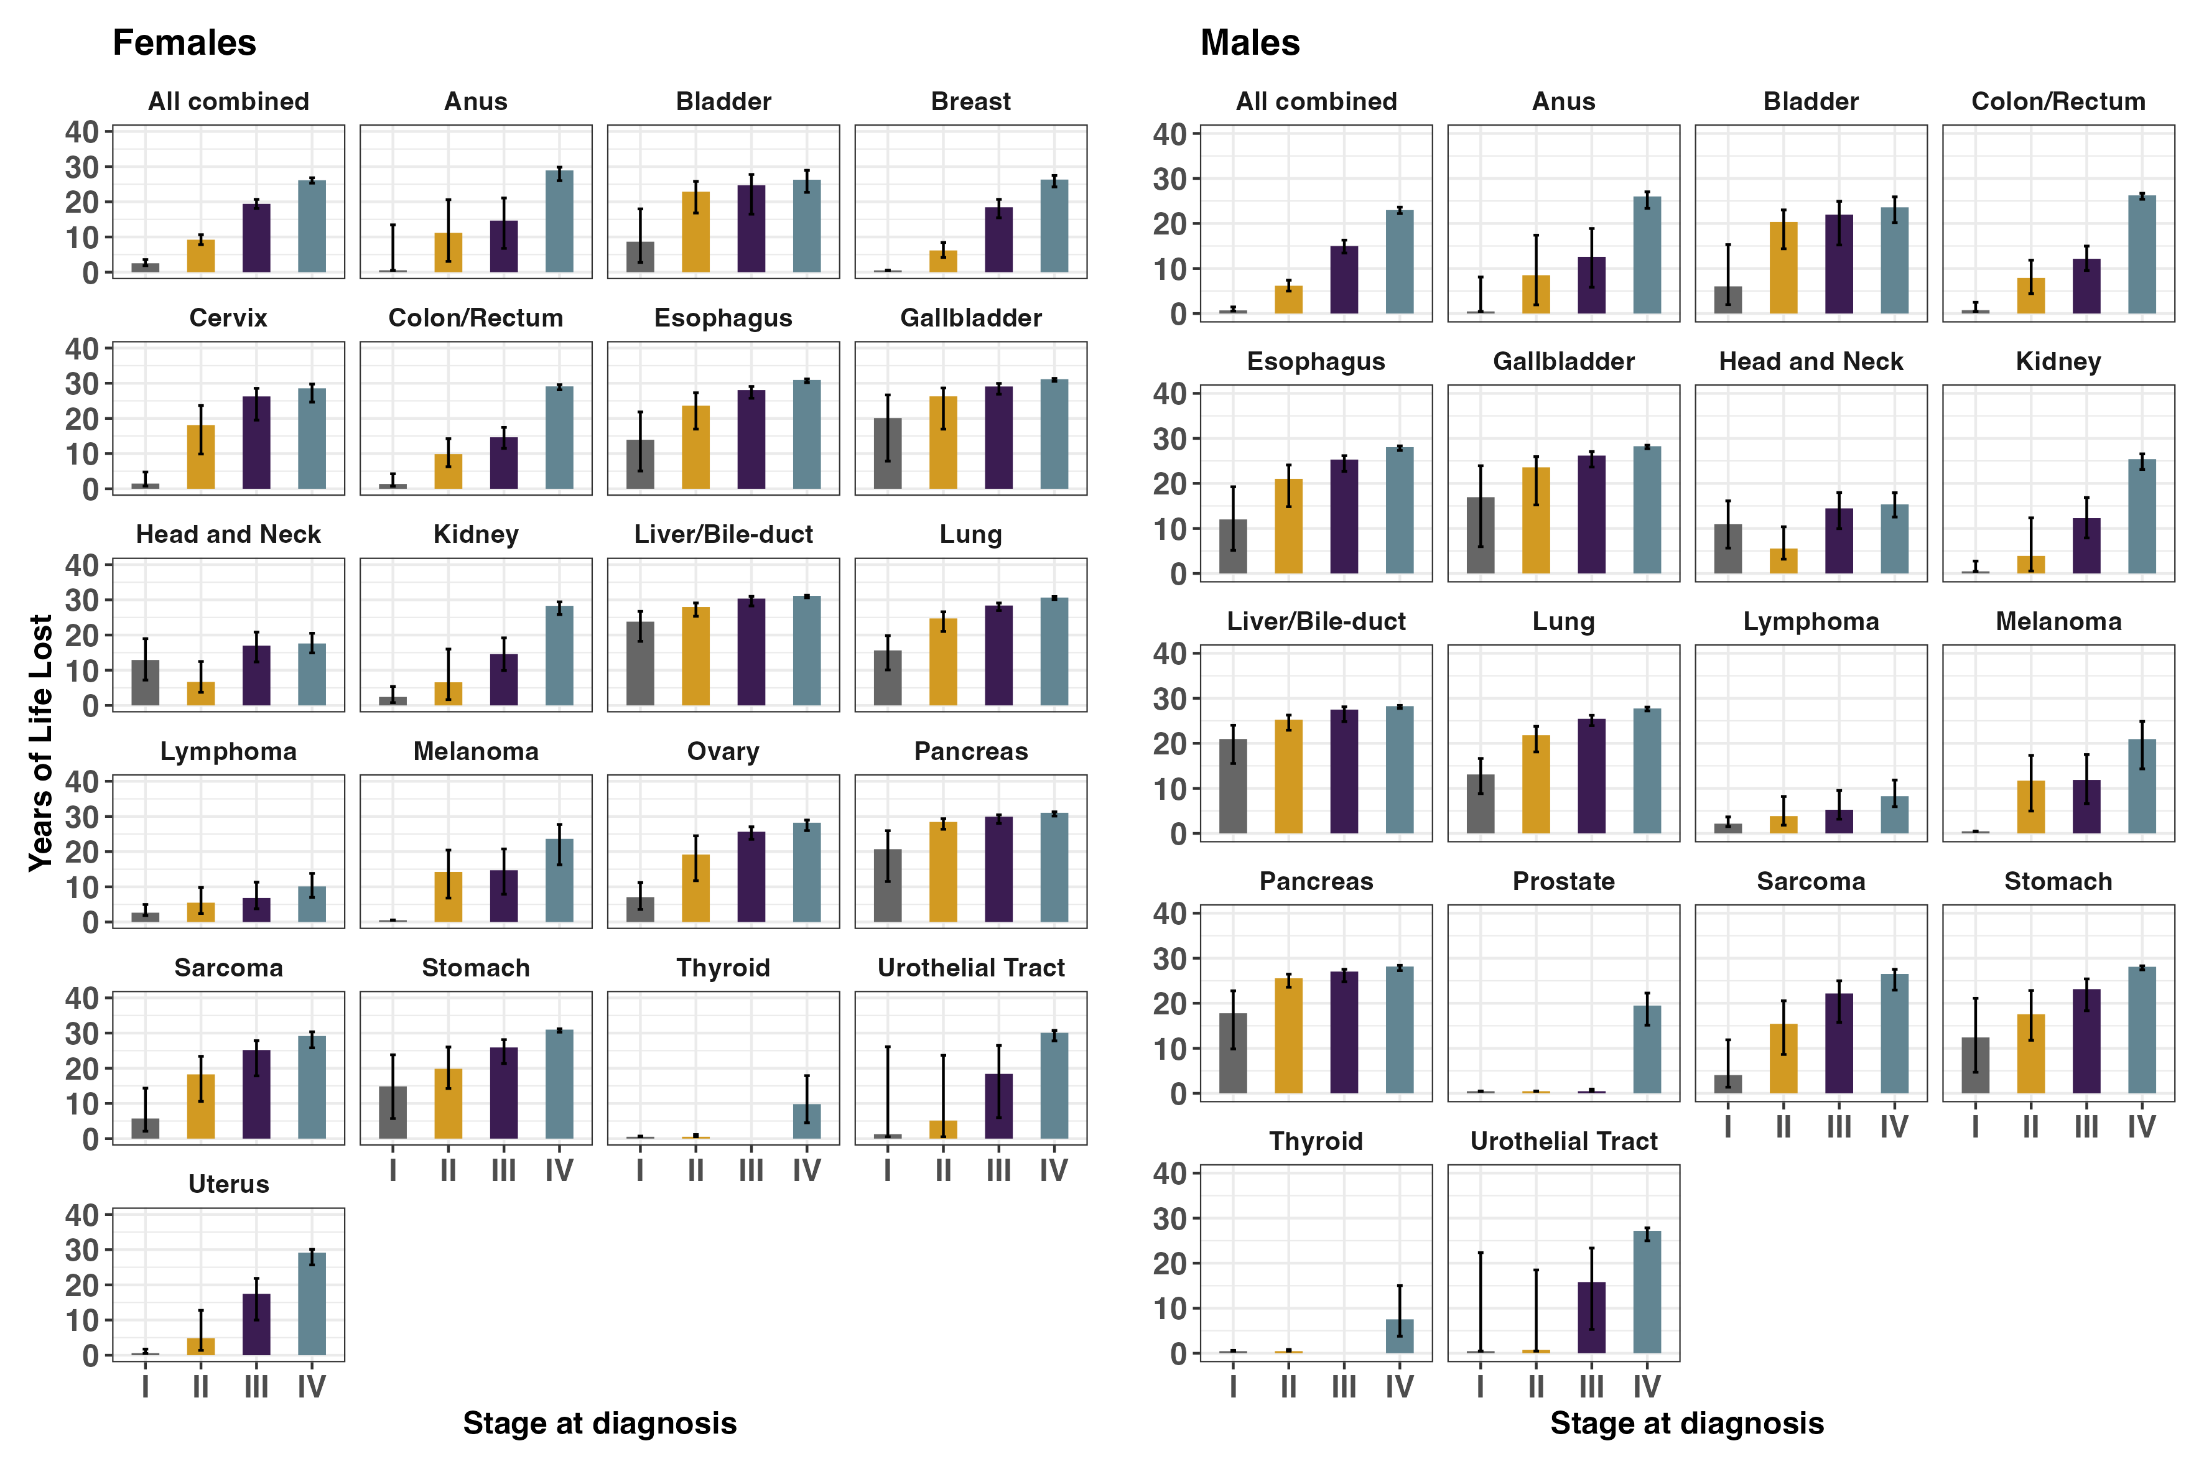

Figure 2: Years of life lost estimates for each cancer type, stage, and gender: 55-59 years at diagnosis
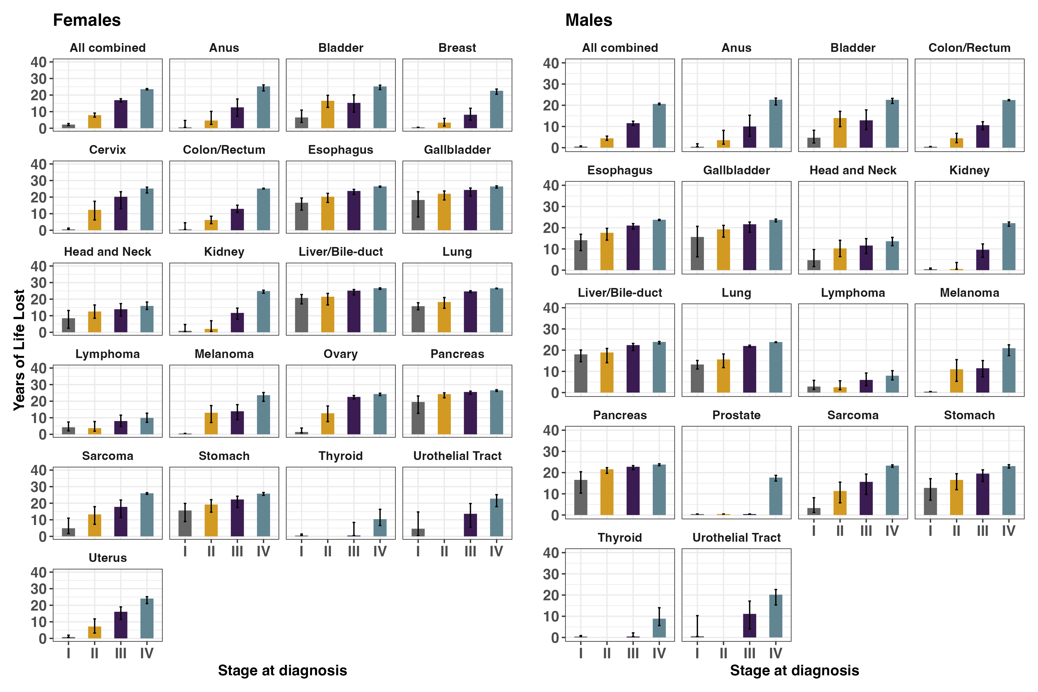

Figure 3: Years of life lost estimates for each cancer type, stage, and gender: 60-64 years at diagnosis
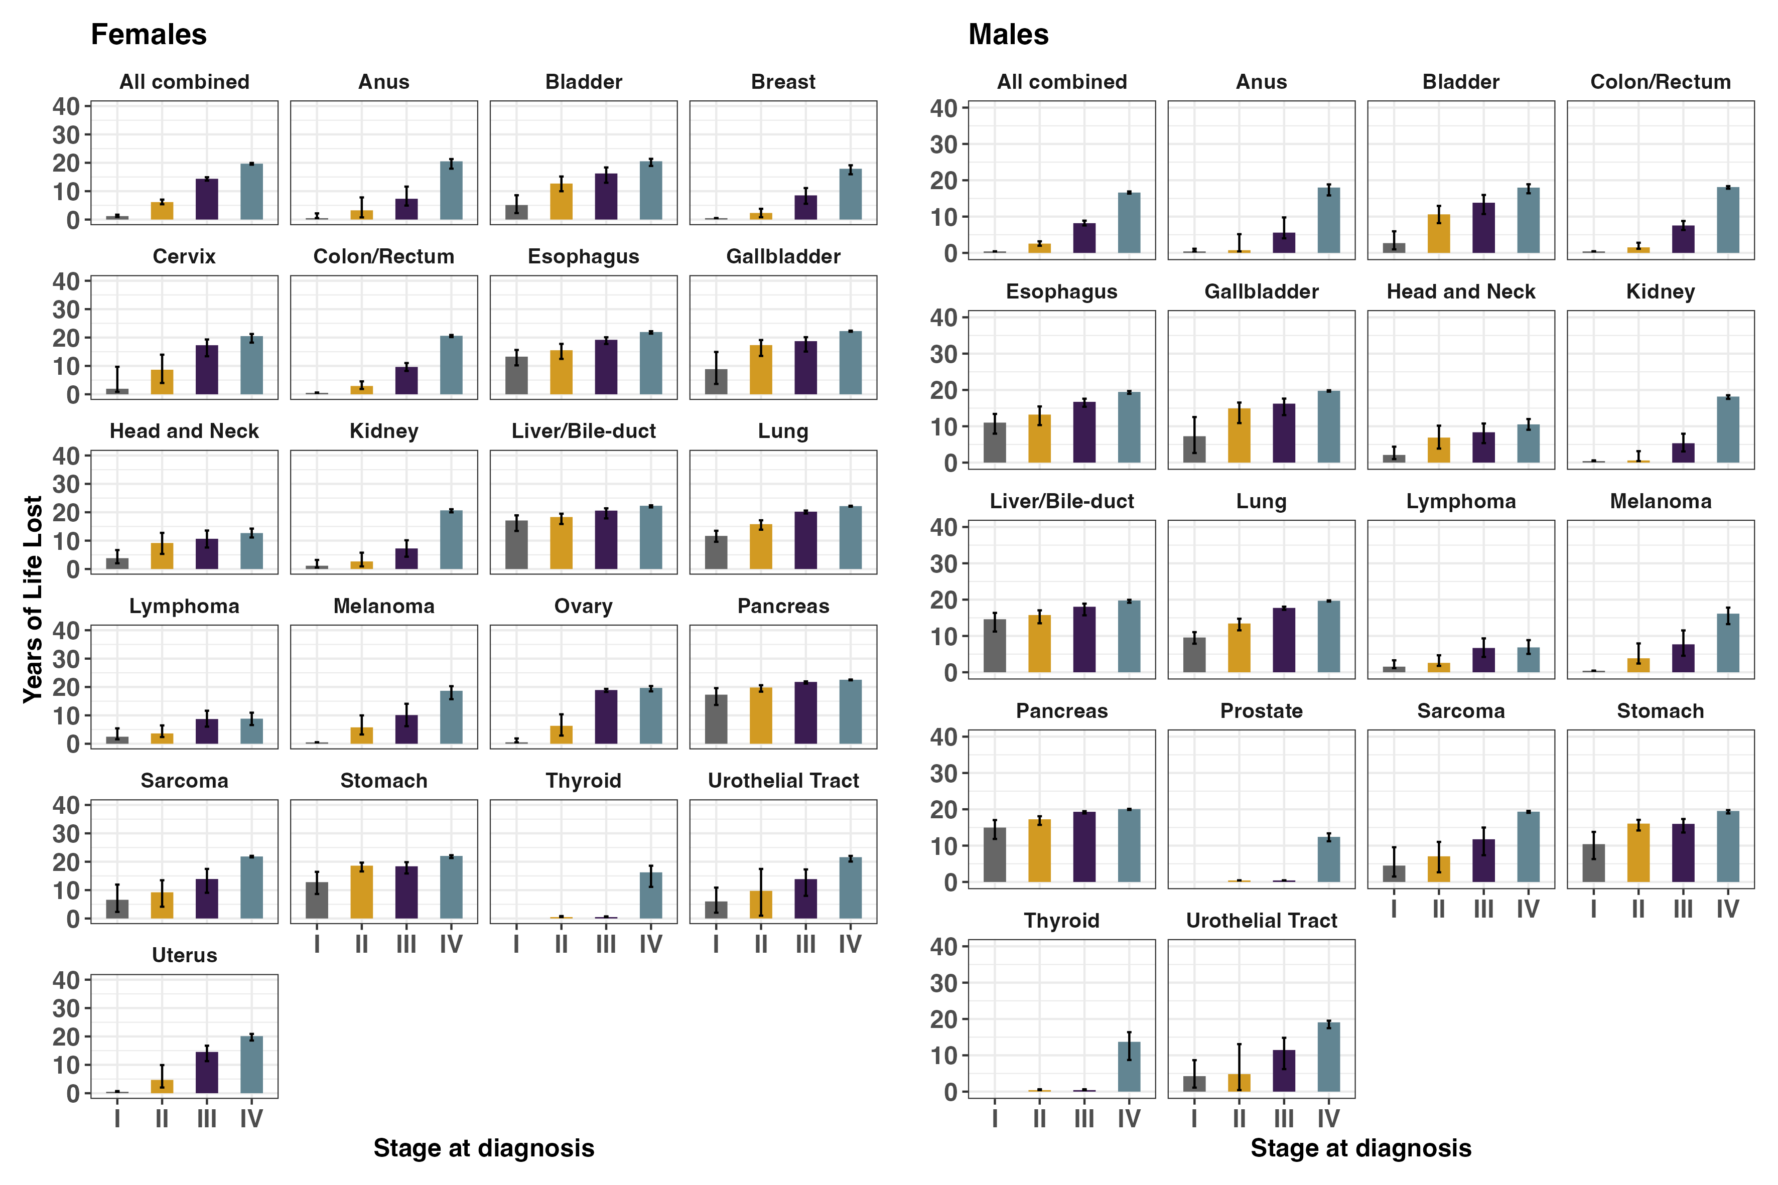

Figure 4: Years of life lost estimates for each cancer type, stage, and gender: 65-69 years at diagnosis
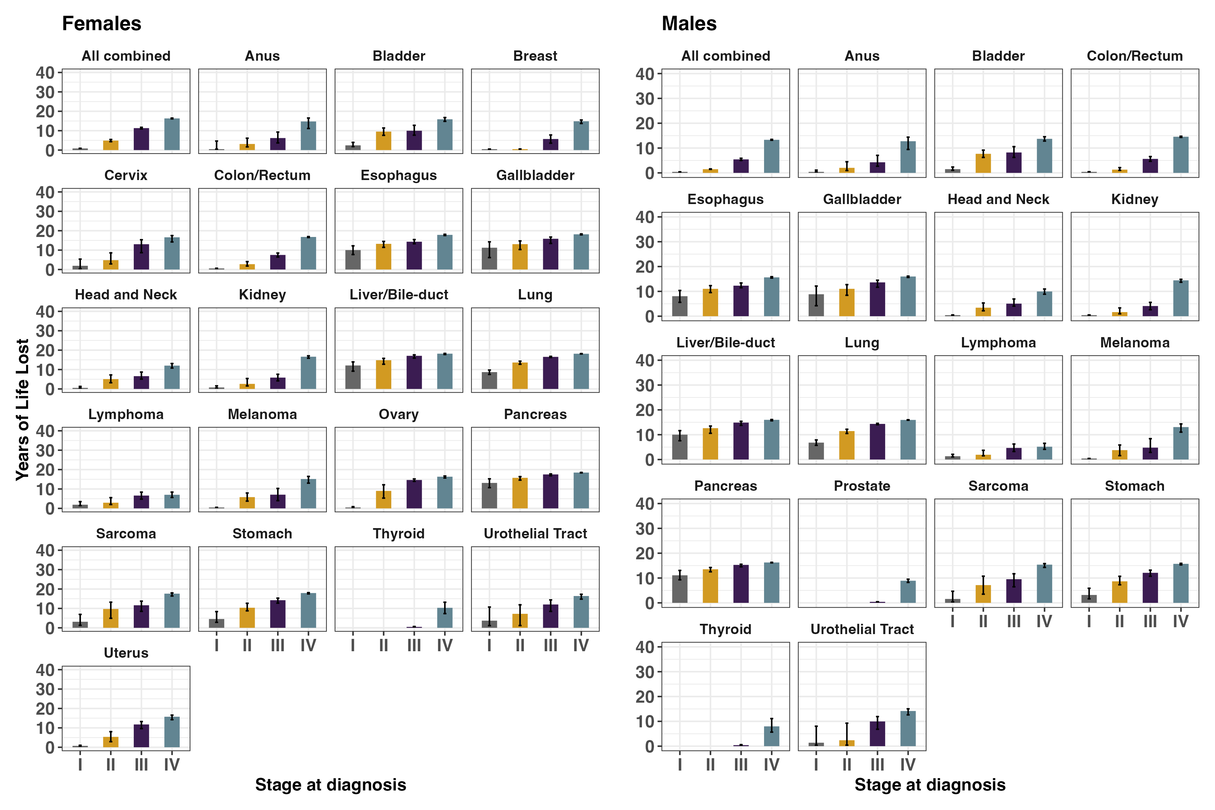

Figure 5: Years of life lost estimates for each cancer type, stage, and gender: 70-74 years at diagnosis
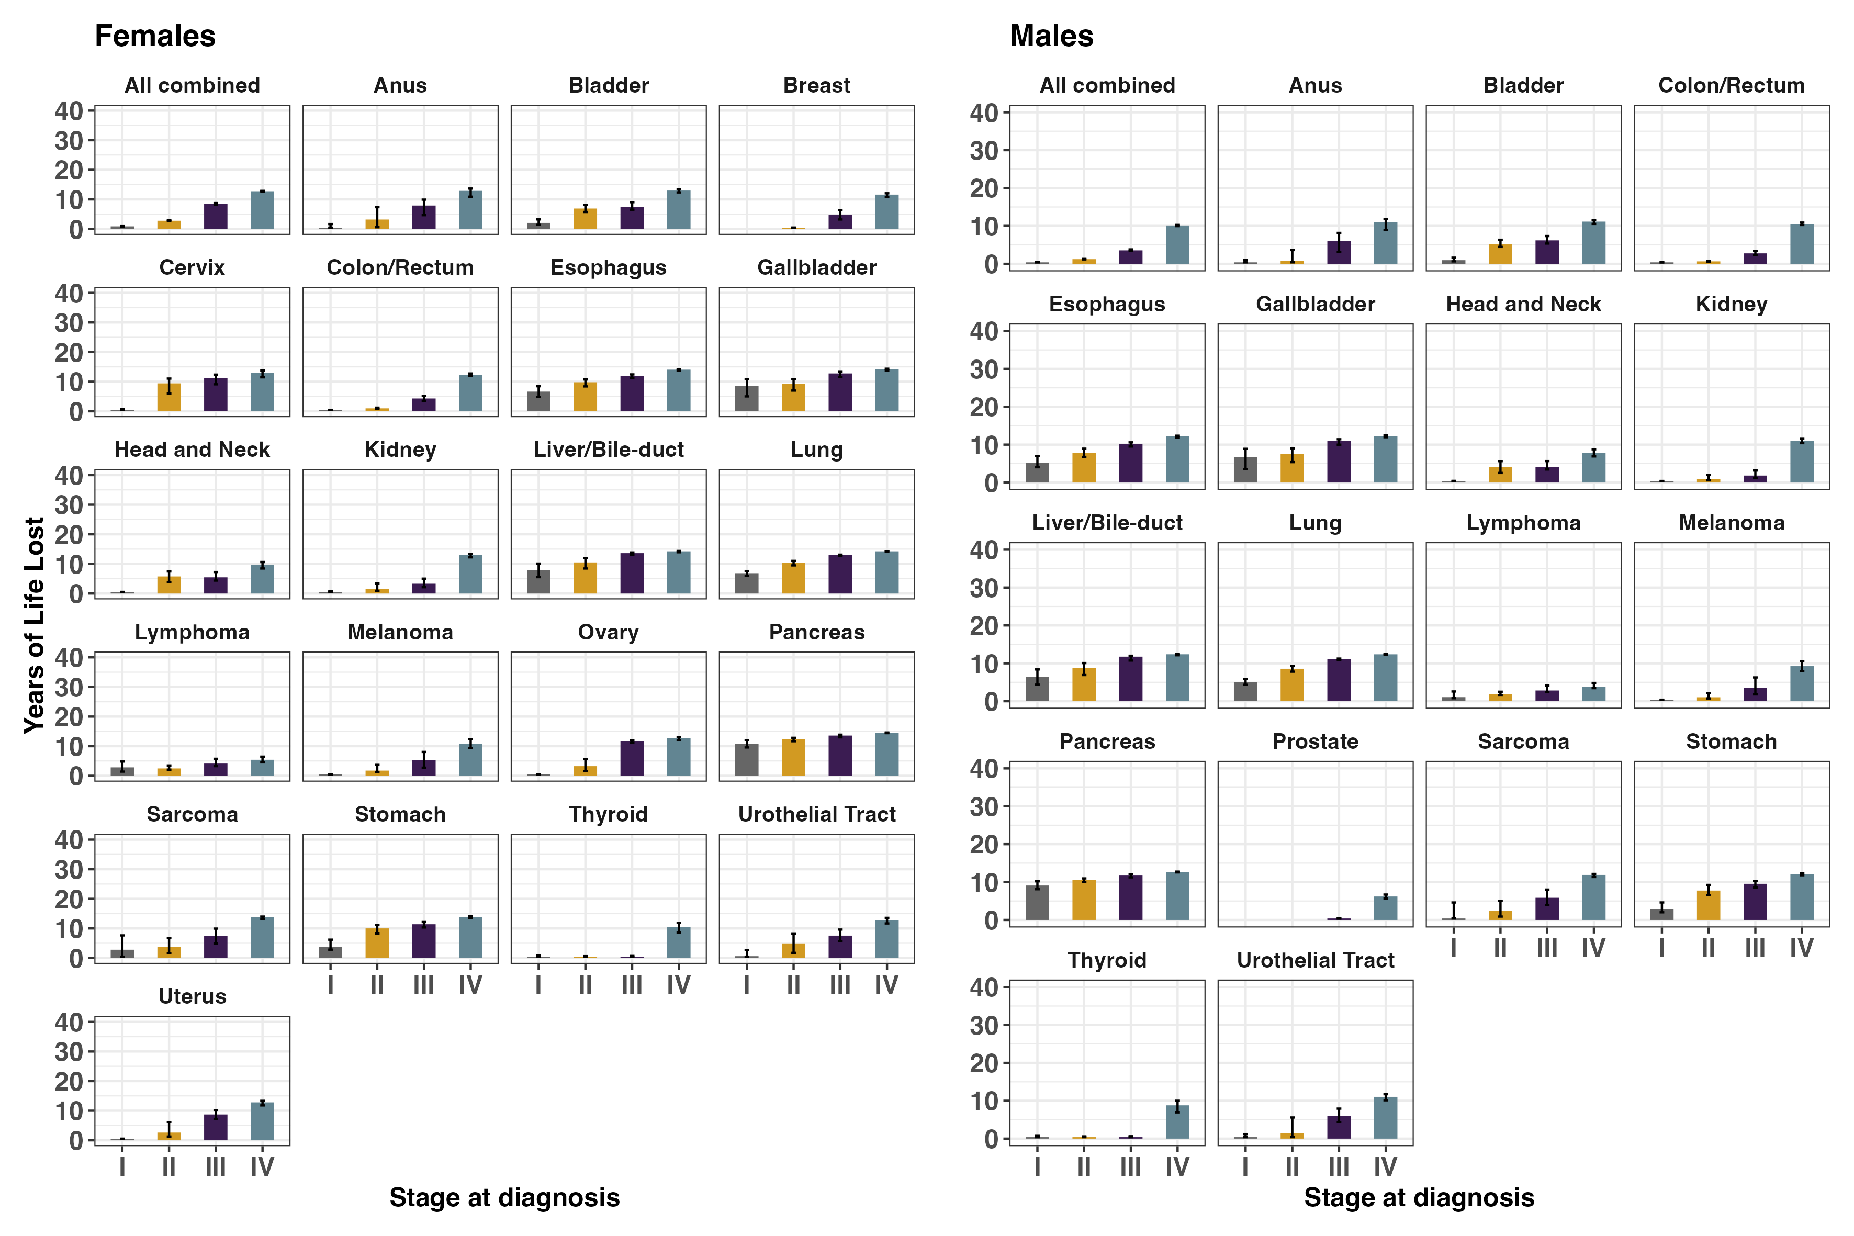

Figure 6: Years of life lost estimates for each cancer type, stage, and gender: 75-79 years at diagnosis
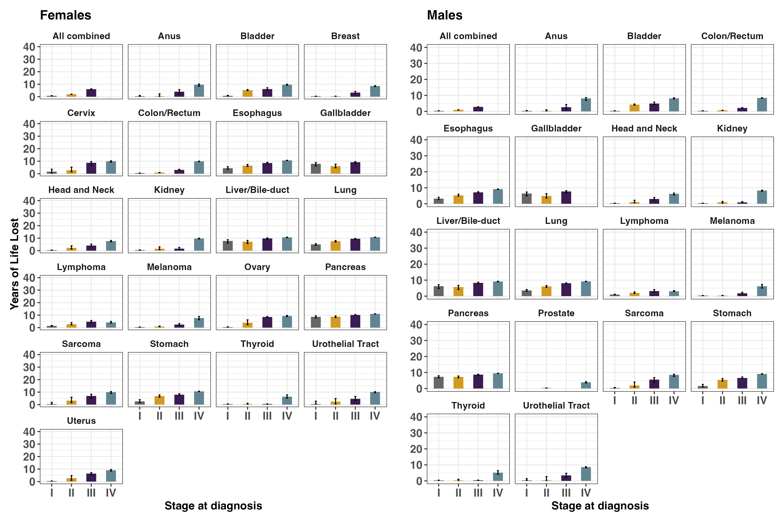

Figure 1: Years of life lost estimates for each cancer type, stage, and gender: 50-54 years at diagnosis
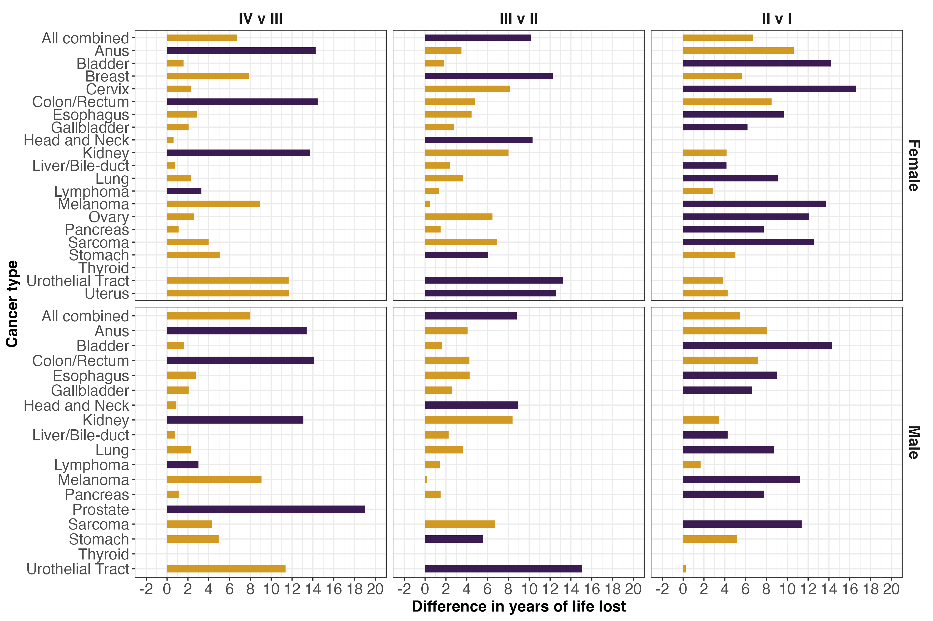

Figure 2: Years of life lost estimates for each cancer type, stage, and gender: 55-59 years at diagnosis
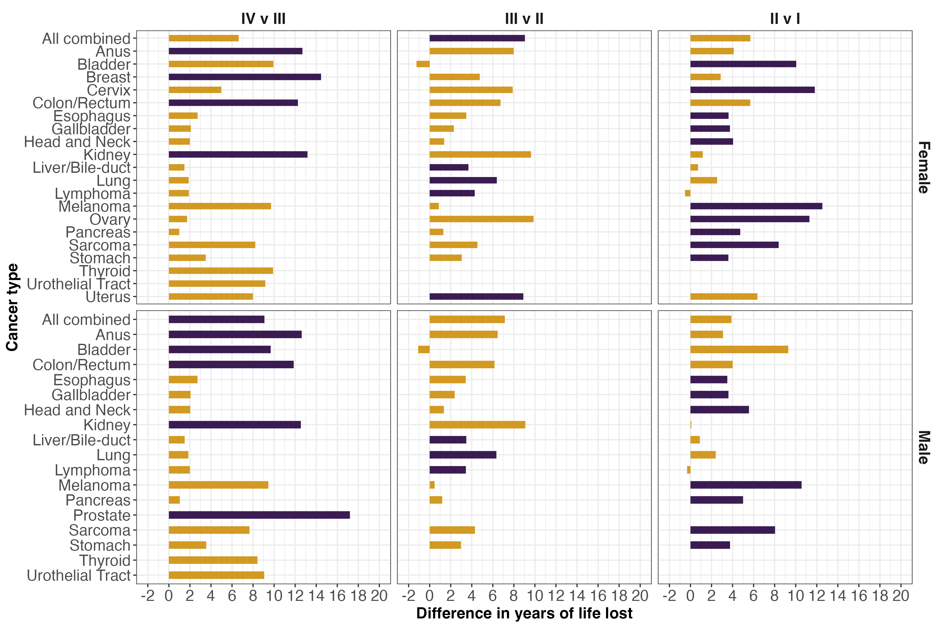

Figure 3: Years of life lost estimates for each cancer type, stage, and gender: 60-64 years at diagnosis
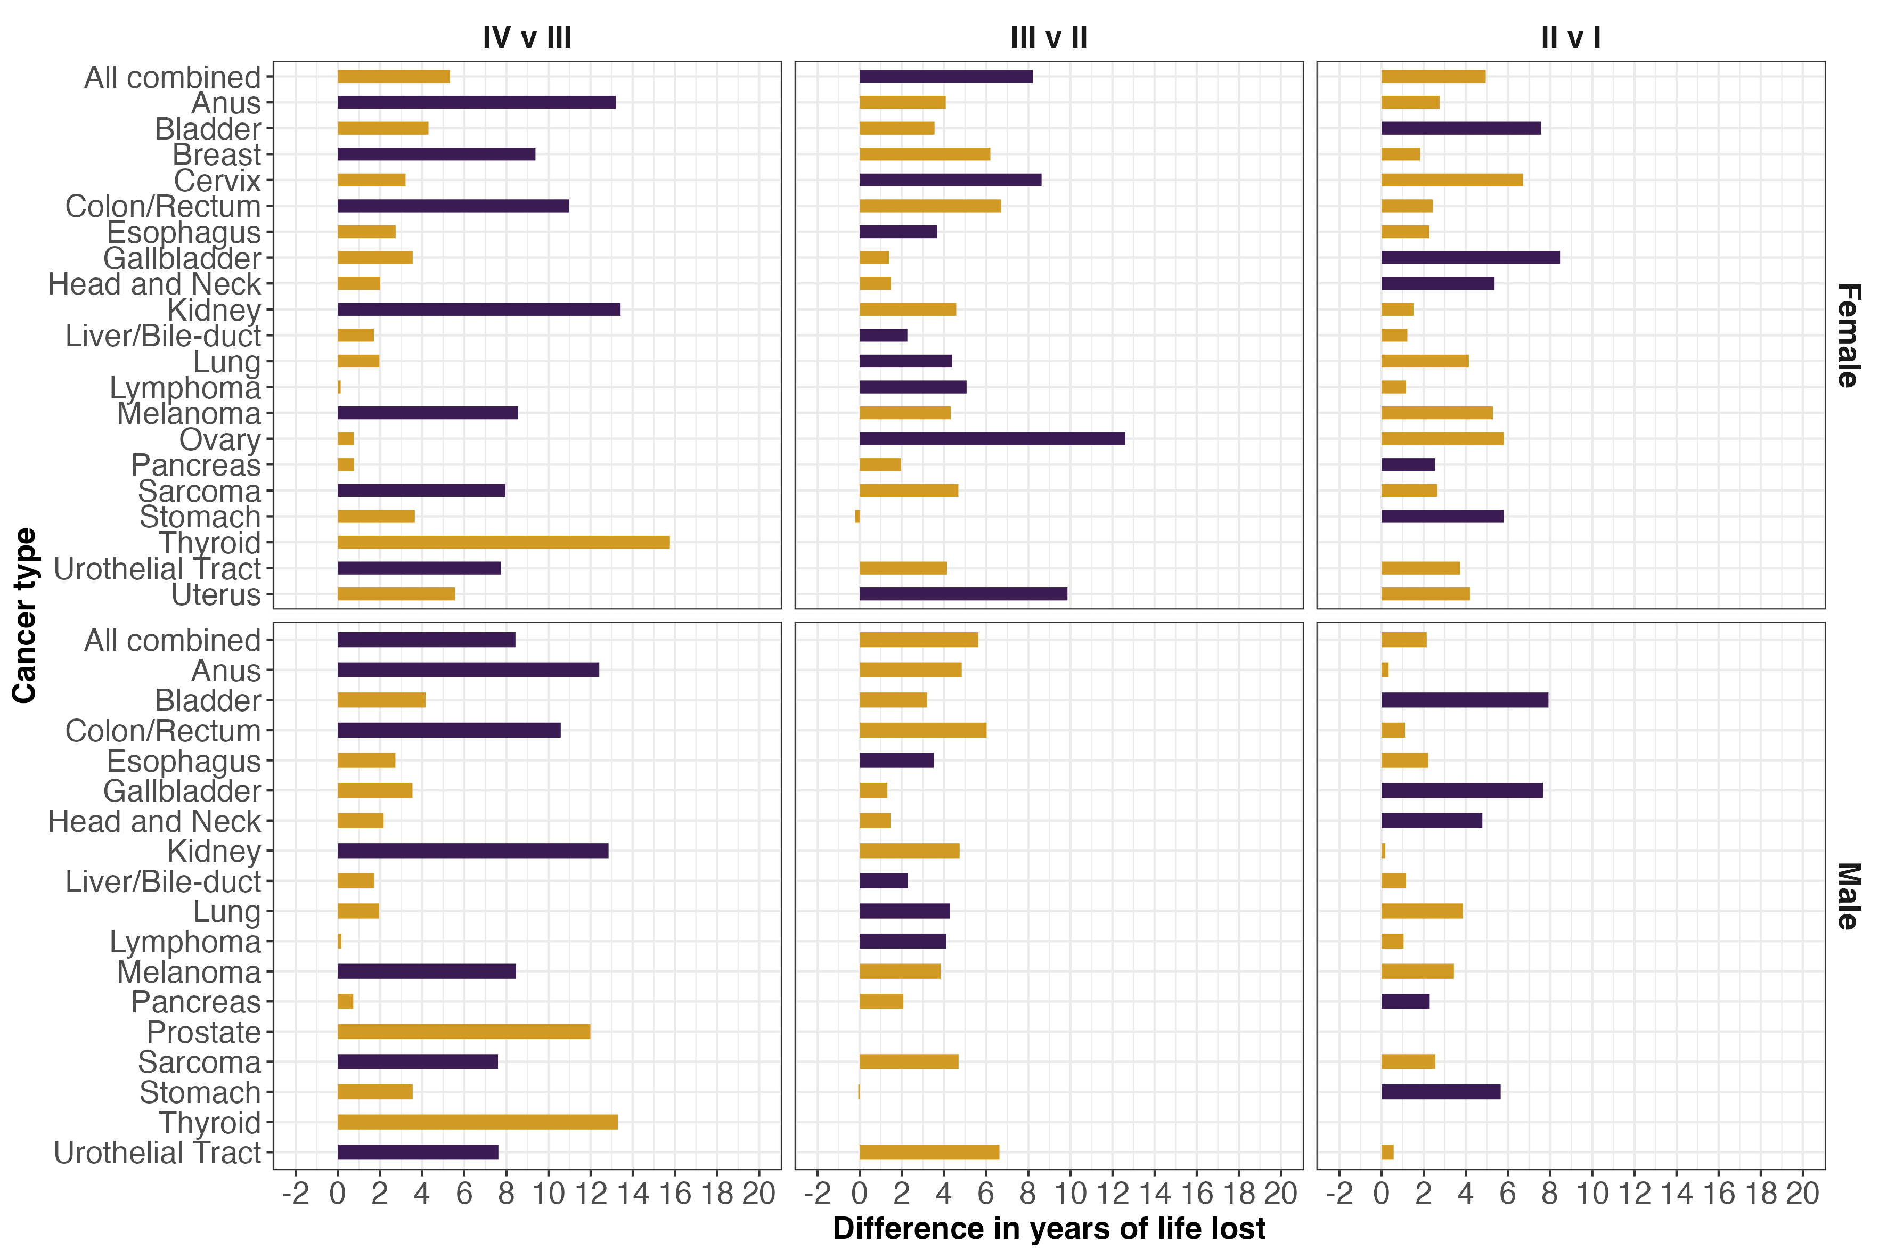

Figure 4: Years of life lost estimates for each cancer type, stage, and gender: 65-69 years at diagnosis
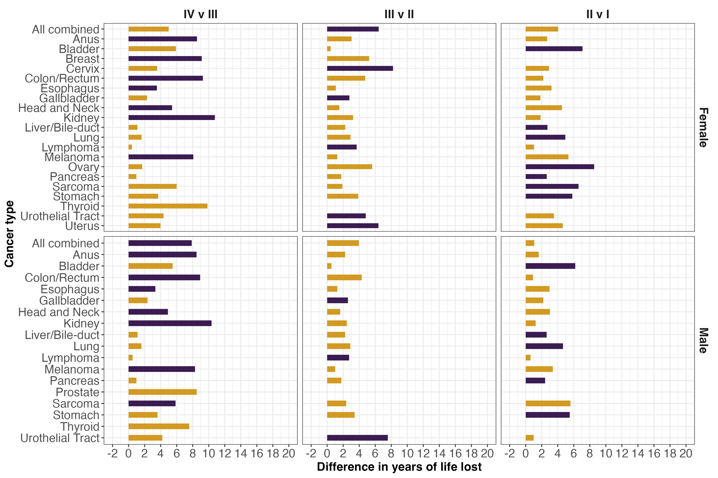

Figure 5: Years of life lost estimates for each cancer type, stage, and gender: 70-74 years at diagnosis
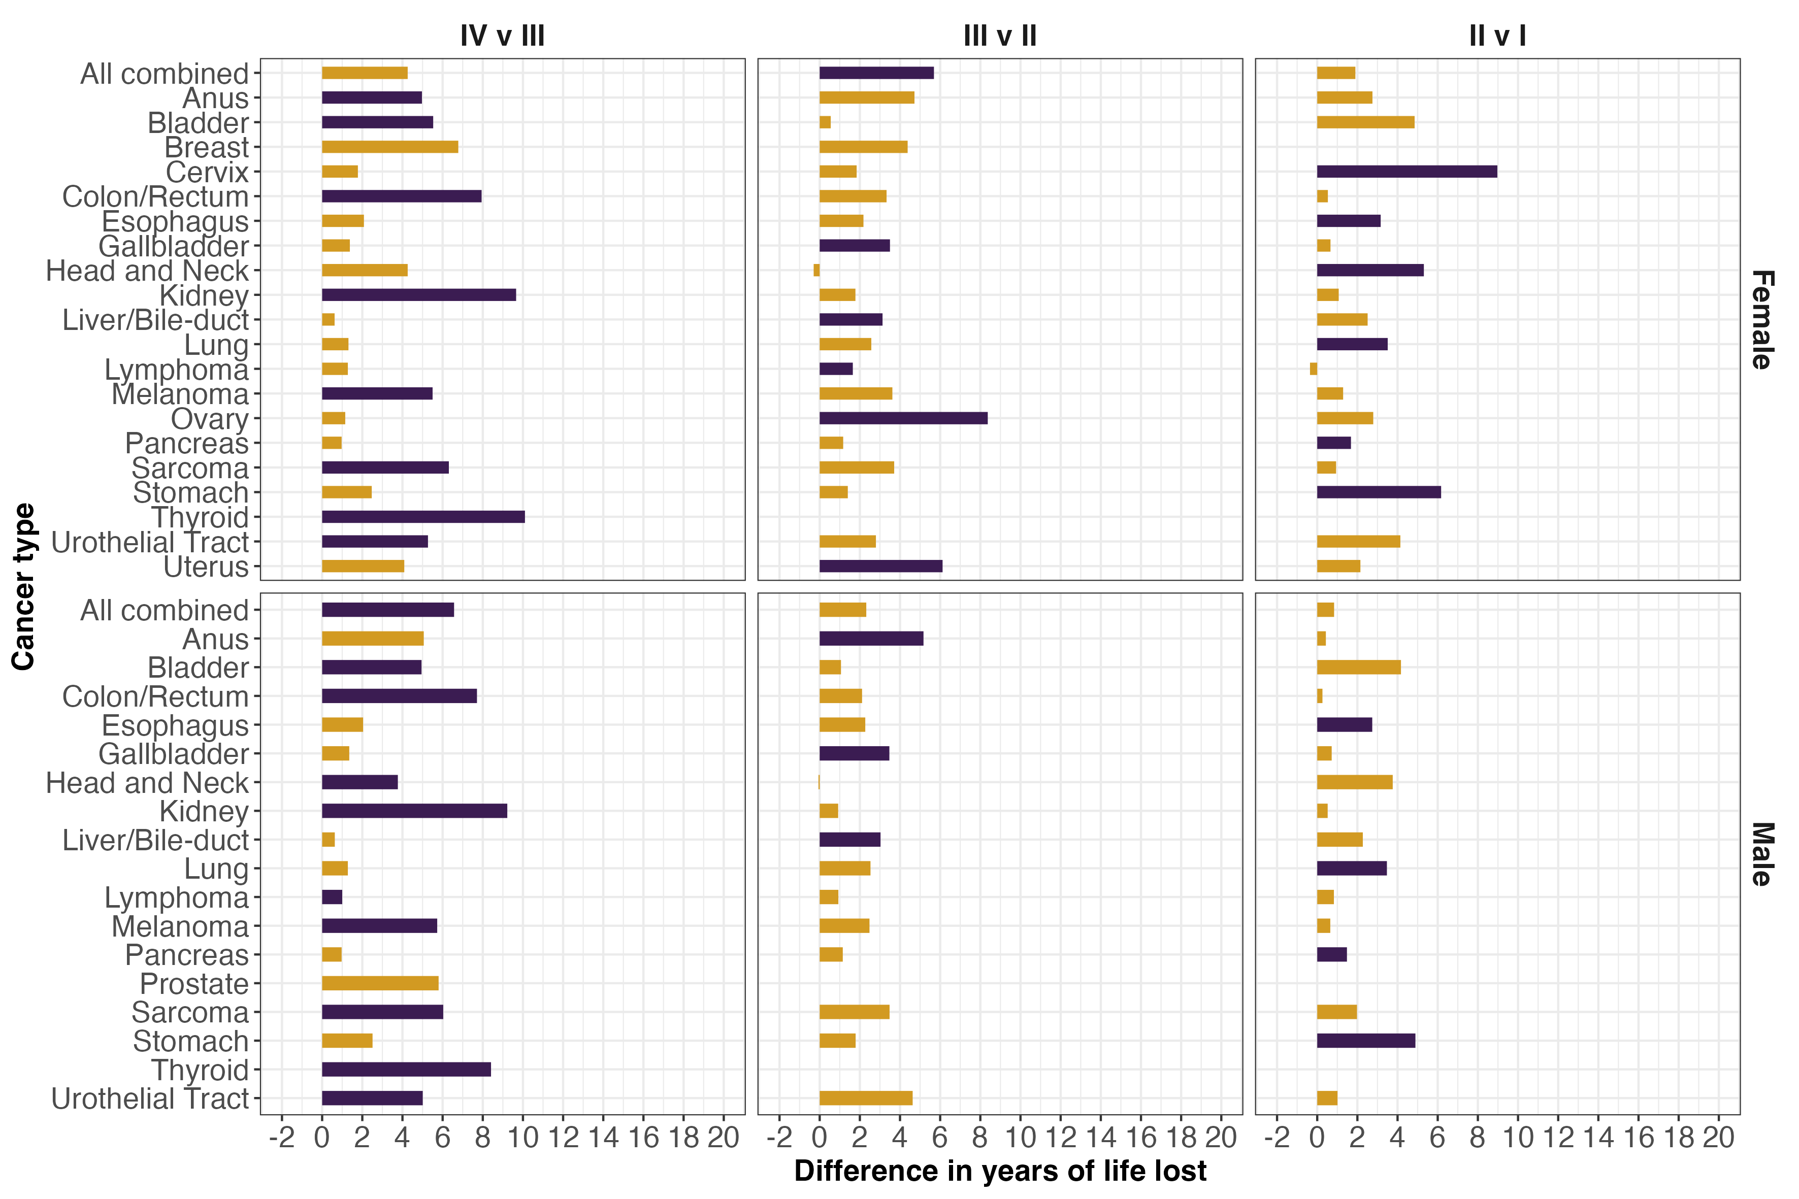

Figure 6: Years of life lost estimates for each cancer type, stage, and gender: 75-79 years at diagnosis
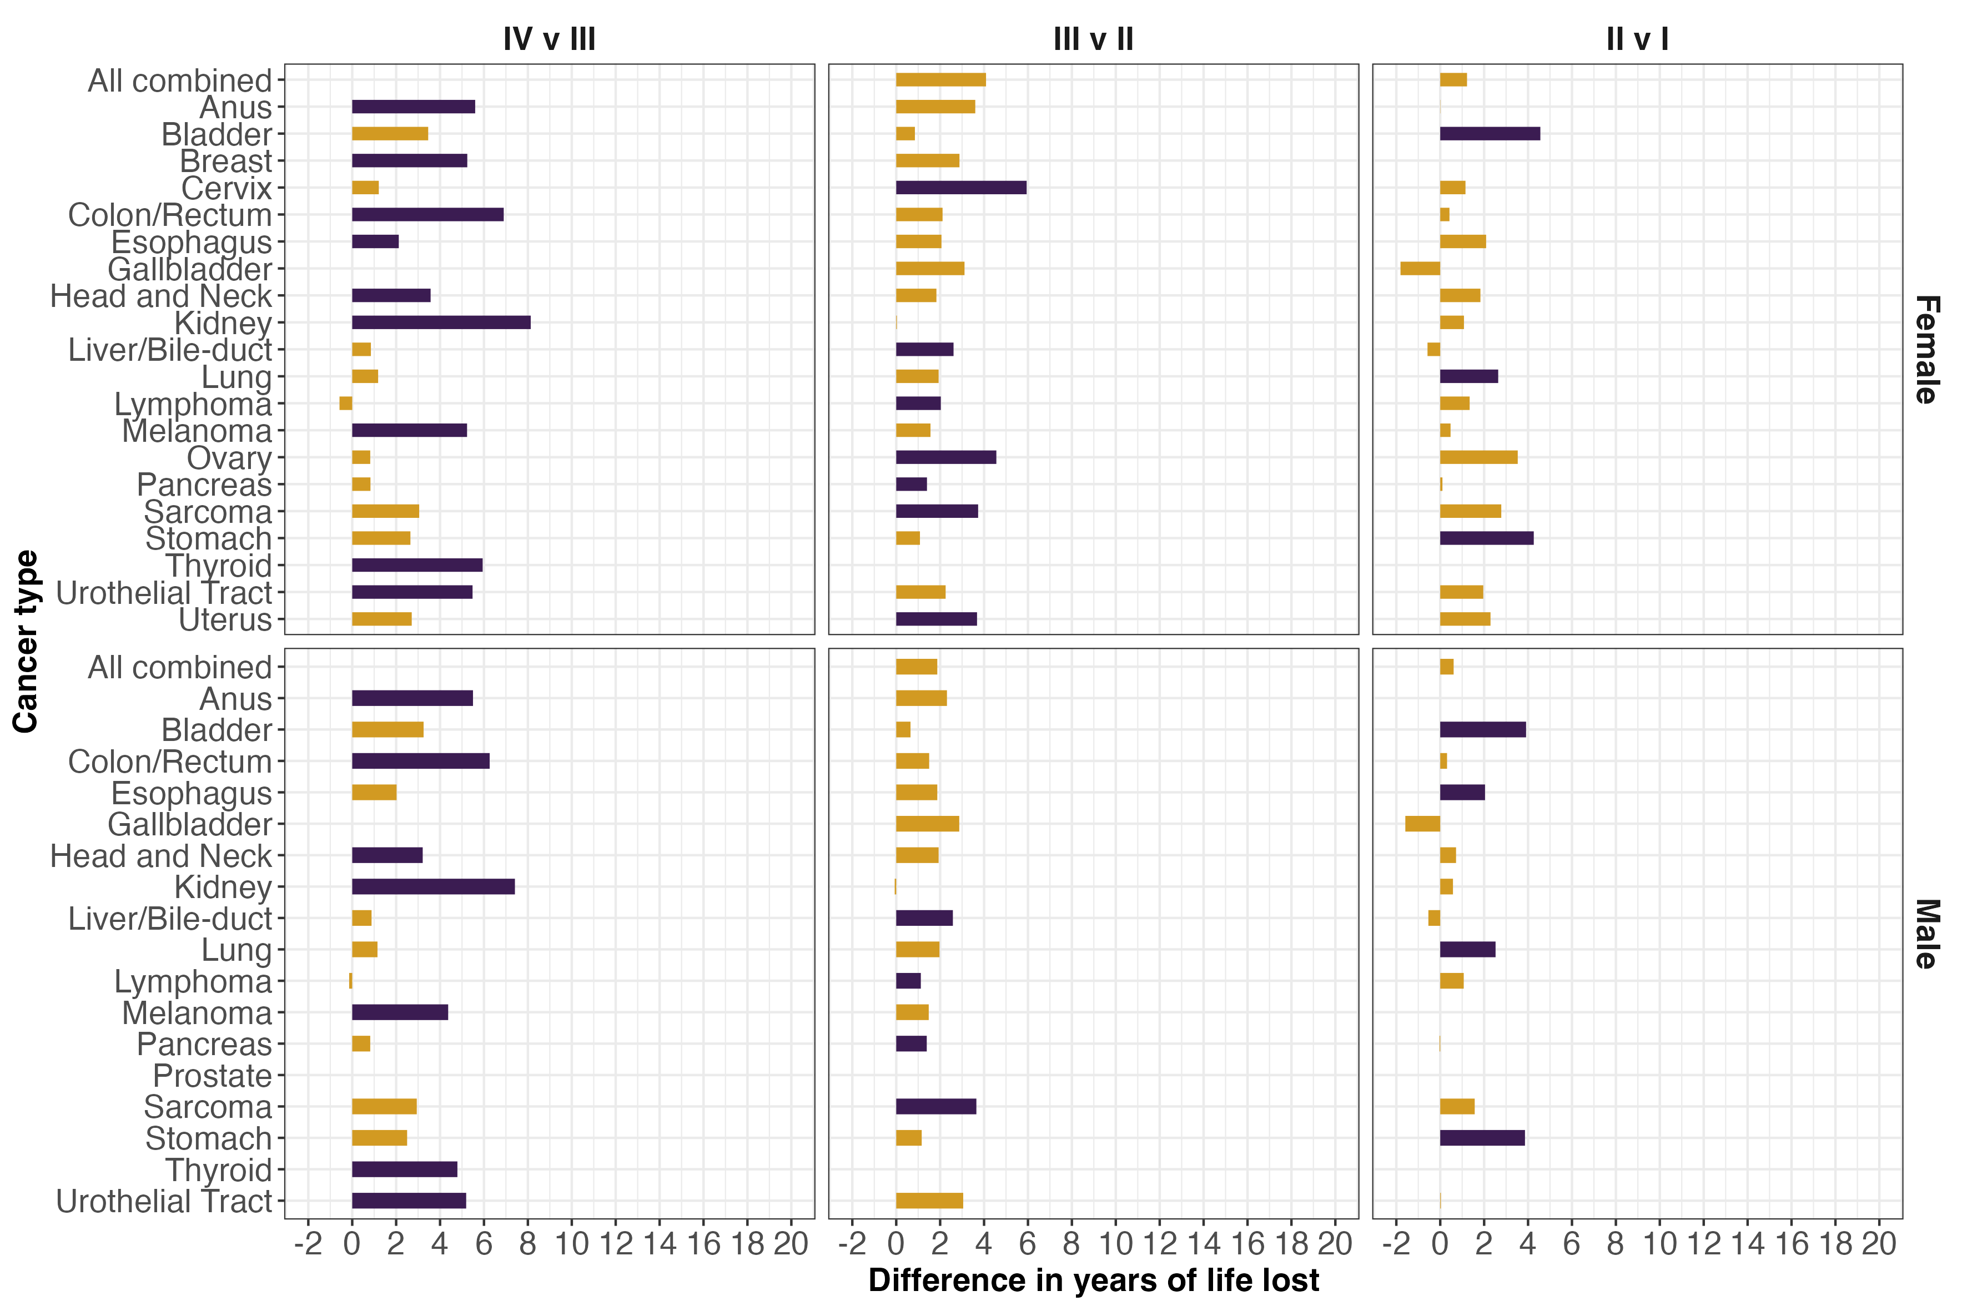

Table 5: Aggregate years of life lost estimates for each cancer type
Cancer type | Stage | Total YLL | Percentage of total YLL
Anus | I | 538.22 | (0.5%)
 | II | 7332.05 | (0.5%)
 | III | 26128.69 | (0.5%)
 | IV | 13596.07 | (0.5%)
Bladder | I | 49016.87 | (3%)
 | II | 103157.59 | (3%)
 | III | 38149.27 | (3%)
 | IV | 113438.37 | (3%)
Breast | I | 30917.52 | (3.7%)
 | II | 131694.76 | (3.7%)
 | III | 104958.51 | (3.7%)
 | IV | 110490.40 | (3.7%)
Cervix | I | 1525.64 | (0.3%)
 | II | 10652.30 | (0.3%)
 | III | 6799.45 | (0.3%)
 | IV | 12900.47 | (0.3%)
Colon/Rectum | I | 19945.27 | (14.2%)
 | II | 121089.89 | (14.2%)
 | III | 444764.47 | (14.2%)
 | IV | 863332.53 | (14.2%)
Esophagus | I | 45328.65 | (6.9%)
 | II | 80166.25 | (6.9%)
 | III | 249194.00 | (6.9%)
 | IV | 331208.85 | (6.9%)
Gallbladder | I | 7664.69 | (1.1%)
 | II | 23580.47 | (1.1%)
 | III | 23841.84 | (1.1%)
 | IV | 56445.32 | (1.1%)
Head and Neck | I | 44529.78 | (6%)
 | II | 49304.03 | (6%)
 | III | 82430.00 | (6%)
 | IV | 432890.54 | (6%)
Kidney | I | 17310.81 | (3.1%)
 | II | 10009.60 | (3.1%)
 | III | 68315.02 | (3.1%)
 | IV | 225036.28 | (3.1%)
Liver/Bile-duct | I | 34538.68 | (2.8%)
 | II | 42725.21 | (2.8%)
 | III | 44130.61 | (2.8%)
 | IV | 160362.98 | (2.8%)
Lung | I | 295532.29 | (34.9%)
 | II | 214558.53 | (34.9%)
 | III | 815892.57 | (34.9%)
 | IV | 2238650.15 | (34.9%)
Lymphoma | I | 26875.51 | (3.4%)
 | II | 28718.46 | (3.4%)
 | III | 78751.96 | (3.4%)
 | IV | 215976.51 | (3.4%)
Melanoma | I | 24424.45 | (1.8%)
 | II | 76688.30 | (1.8%)
 | III | 44822.82 | (1.8%)
 | IV | 32978.16 | (1.8%)
Ovary | I | 11849.79 | (2.2%)
 | II | 11227.04 | (2.2%)
 | III | 127778.27 | (2.2%)
 | IV | 78794.65 | (2.2%)
Pancreas | I | 34105.10 | (7.3%)
 | II | 103036.80 | (7.3%)
 | III | 92535.25 | (7.3%)
 | IV | 520015.53 | (7.3%)
Prostate | I | 4752.03 | (2.7%)
 | II | 7614.25 | (2.7%)
 | III | 13893.64 | (2.7%)
 | IV | 251105.75 | (2.7%)
Sarcoma | I | 7382.10 | (0.7%)
 | II | 14852.55 | (0.7%)
 | III | 22229.64 | (0.7%)
 | IV | 31059.10 | (0.7%)
Stomach | I | 17952.76 | (3.7%)
 | II | 49808.28 | (3.7%)
 | III | 86653.85 | (3.7%)
 | IV | 226172.39 | (3.7%)
Thyroid | I | 1254.90 | (0.3%)
 | II | 452.97 | (0.3%)
 | III | 695.26 | (0.3%)
 | IV | 23411.90 | (0.3%)
Urothelial Tract | I | 2621.47 | (0.6%)
 | II | 2894.52 | (0.6%)
 | III | 14847.76 | (0.6%)
 | IV | 37096.45 | (0.6%)
Uterus | I | 13385.72 | (0.9%)
 | II | 8733.03 | (0.9%)
 | III | 36020.94 | (0.9%)
 | IV | 30801.13 | (0.9%)

Figure 7: Distribution by index cancer type and stage of the total estimated years of life lost for the 1,338,861 incident cases across the 21 cancer types diagnosed between 2013 and 2019 in individuals ages 50 to 79.
